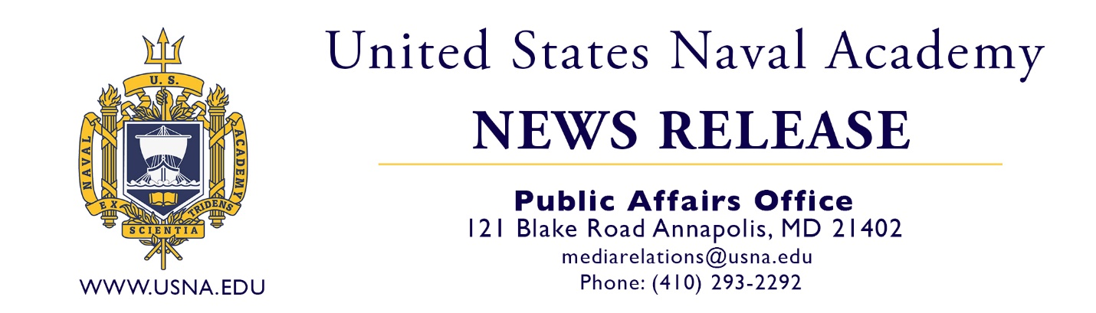

MEDIA CONTACTS: Elizabeth Wrightson, Colleen Krueger, Madelyn Flayler
PAO: Cmdr. Alana Garas
Month ##, 2022
FOR IMMEDIATE RELEASE

NOTE to Editors and Reporters: Please contact the person submitting this release for additional information about the graduate. Please contact the Naval Academy Public Affairs Office for any questions about the academy or for a yearbook photo of the graduate.

1_____ NATIVE GRADUATES FROM THE U.S. NAVAL ACADEMY

ANNAPOLIS, Md. – 2_____ of 3____, 4_____ successfully completed four years of challenging academic, physical and professional military training, graduating from the U.S. Naval Academy with a Bachelor of Science degree in 5______ and a commission as a 6______________. 7_____ is a graduate of 8________.
At the academy 9_____ was a member of the 10__________.
Founded in 1845, the U.S. Naval Academy today is a prestigious four-year service academy that prepares midshipmen morally, mentally and physically to be professional officers in the naval service. More than 4,400 men and women representing every state in the U.S. and several foreign countries make up the student body, known as the Brigade of Midshipmen. U.S. News and World Reports has recognized the Naval Academy as a top five undergraduate engineering school and a top 20 best liberal arts college. Midshipmen learn from military and civilian instructors and participate in intercollegiate varsity sports and extracurricular activities. They also study subjects such as leadership, ethics, small arms, drill, seamanship and navigation, tactics, naval engineering and weapons, and military law. Upon graduation, midshipmen earn a Bachelor of Science degree in a choice of 27 different subject majors and go on to serve at least five years of exciting and rewarding service as commissioned officers in the U.S. Navy or U.S. Marine Corps.
The Brigade of Midshipmen is comprised of approximately 4,400 students from every state in the union. Each year, approximately 1,200 young men and women are admitted to the Naval Academy’s incoming class.
The academy’s alumni include, one president, 21 members of Congress, five governors, 73 Medal of Honor recipients, two Nobel Prize winners, 54 astronauts and 4,000 admirals and generals.
USNA

