Optical Deflection Measurement System for Out-of-Plane Dynamic Measurement of Microelectromechanical Systems
Example Laboratory Report for EE426, Fall 2012

MIDN 1/C Sam Doright
Electrical Engineering (put major here)
United States Naval Academy
Annapolis, Maryland
m951111@usna.edu

Abstract— (The abstract is not the same as an introduction—it is a snapshot of the *entire* paper) Nonintrusive measurement of small out-of-plane motions of microscale structures is critical to the development of microelectromechanical systems (MEMS). This paper presents a low-cost deflection measurement system for MEMS structures based on a fiber optic displacement sensor. The system is demonstrated in the characterization of a microwave switch. The deflection system had a demonstrated sensitivity of 290 ± 32 μV/nm over a deflection range of 100 μm. The calibration and linearity of the system is described, and the static and dynamic performance is compared to more elaborate systems.

Introduction
(The intro does not need to be as long as this example. It does need to describe the reason that the work was undertaken and how the work fits into the “big picture.” So for an instrumentation paper you would want to describe what you are measuring, why measuring it is useful, and also summarize the different methods that are used for making the measurement. Always cite your sources.) Microelectromechanical systems (MEMS) are being widely explored for a variety of applications, including microwave and RF communications [1-4], optical networking [5-7], and acoustic [8] and mechanical sensors [9]. These systems all contain small plates, bridges or cantilevers in the size scale of tens to hundreds of micrometers, with out-of-plane motion on the scale of tens of nanometers to micrometers. Since it is the vertical motion that is usually critical to device operation, accurate measurement of these small movements is essential to characterize device behavior. Thus, an immediate need for any MEMS researcher is the ability to quantify small out-of-plane deflections that are often not apparent by eye with a conventional optical microscope.
Out-of plane deflection in MEMS has been measured by a variety of techniques, including capacitive sensing [10-12], piezoresistive sensing [13] and optical methods. While extremely high sensitivity has been demonstated with capacitive sensing, microfabricated capacitive sensors often require on-chip electronics due to the small capacitance changes involved [11]. This work has focused on optical deflection detection methods, because it requires no modification to the device under test.
A variety of custom systems have been developed to meet this need, relying on interferometry [14-17] or on changes in deflection angle [18, 19]. Such systems require a significant amount of development time. Alternatively, there are a variety of commercial deflection detection systems that have been developed for microsystems metrology; however these commercial systems are often prohibitively expensive for a small research group. This paper details how an inexpensive fiber-optic displacement sensor can be quickly adapted to measure out-of-plane deflection in microsystems. The performance and capabilities of this simple system are then compared to more elaborate commercial systems especially designed for MEMS characterization.
Calibration is achieved by taking advantage of the “pull-in” effect. The pull-in voltage for a given structure is repeatable and predictable [20, 21], although dielectric charging can result in drift of the pull-in voltage over the operation lifetime of the device [22-24]. The pull-in effect been investigated for the realization of a DC voltage reference [25], rms-to-dc converter [26], and material property test [27]. In this system, the pull-in effect provides a deflection reference for in situ calibration. Since we are using pull-in only to calibrate the deflection sensitivity of the device, charging-induced drift of the pull-in voltage is not a concern in this method.

Experimental Method
(This section should describe the entire instrumentation system, including a block diagram of the system, any circuits used (with component values specified), screenshots of any GUIs created, a description of algorithms performed by LabVIEW or MATLAB, and descriptions of the calibration procedure.) The complete system is shown in Fig. 1. The microscopic deflection measurement system used a fiber optic displacement sensor based on a simple reflection principle. The sensor head was a fiber optic bundle with a mixture of transmitting and receiving fibers. Deflection was measured as a change in the proportion of reflected light captured by the bundle. A Philtec model D6 deflection sensor was chosen because it had the smallest sensor head of those available. This particular sensor used a 670 nm laser diode as its source.

Figure 1. Block diagram of deflection measurement system (Figures should be centered, labeled and captioned and should appear near to where they are referenced in the text. The text in the figures should be legible).
In addition to the sensor unit, the system also included a long-working distance microscope, a stage for mounting the device, and a micromanipulator for controlling the fiber optic head. The system also required DC power, a function generator to excite the test device, and a voltmeter and lock-in amplifier to monitor the output. A PC equipped with LabVIEW® was used to log data. The only requirement of the device under test is that it must be optically accessible.

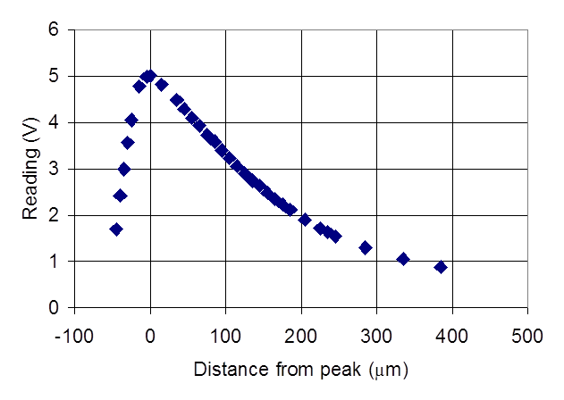
Figure 2. Plot of voltage output versus sensor position for the Philtec fiber optic displacement sensor

The signal output as a function of position is illustrated in Fig. 2. The position was referenced to the point of maximum signal so that the sensor could be positioned without bringing it into contact with the device under test. There are two linear operation ranges for the sensor. In near-field operation the sensor head was suspended about 75 μm above the object, and in far-field operation the sensor head was suspended about 400 μm above the object. The sensor had a nominal sensitivity of 52.5 μV/nm in the near field and 6.8 μV/nm in the far field at frequencies up to 20 kHz. In practice, the sensitivity varied almost two orders of magnitude, depending on the device surface, the orientation of the fiber, and the setting of the fiber optic signal amplifier. Useful data could be obtained even at low sensitivities. The bundle diameter for the fiber optics sensor was 150 μm, which exceeds the dimension of many MEMS devices. However, this work shows that it could still be used with devices with size scales on the order of 100 μm.
The deflection detection system was developed for monitoring the out-of-plane motion of a MEMS microwave switch. The active arm of the switch was an electroplated gold bridge, formed by surface micromachining and suspended about 2 μm above the substrate. The bridges were 220 μm long, 1.5 μm thick and 100 μm in width (Fig. 3). The stationary electrode, also made of gold, was insulated from the upper electrode during pull-in by a thin layer of silicon nitride.

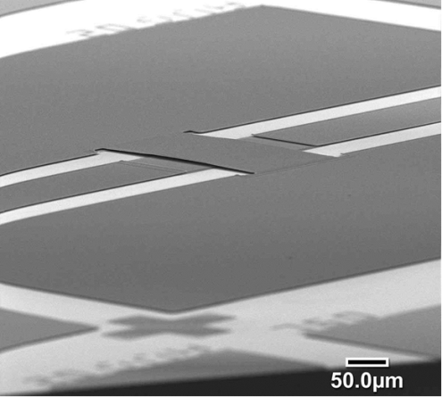
Figure 3. A scanning electron photomicrograph of the planar microwave switch used with the measurement system.

Since the sensitivity of the sensor was highly dependent on position and orientation, it was calibrated in operation position. First, the sensor head was approximately positioned over the bridge, turned on and allowed to stabilize for about ten minutes. The height of the sensor head was adjusted until a peak value was observed, and the sensor amplifier gain was adjusted to obtain a 5 V maximum signal. Then the sensor head was brought into the far-field position. Far-field operation was preferred over near-field because alignment was less critical and there was a broader linear range. A 1 kHz sinusoidal signal was applied to the device and the output monitored. Fine adjustments were then made to the position of the sensor in the horizontal plane to maximize the signal. Once aligned, the overall output voltage versus separation curve, such as is shown in Fig. 2, was found by leaving the bridge stationary and using the z-axis micrometer on the micromanipulator to adjust vertical position.
Using the large-signal calibration curve, the sensor head was then brought into the far-field operation position above the device. Then a series of DC voltages were applied to the bridge while the output signal was monitored. The output signal change that corresponded to pull-in was detected and used with the known initial gap dimension to determine the sensitivity of the device in operation position. The calibration was therefore referenced to the deflection at the center of the beam, and not to average deflection. This calibration also assumed that the frequency response of fiber optic sensor was flat over the range of operation. Applying a large sinusoidal voltage to measure the pull-in signal at the desired operation frequency would result in a more accurate calibration, requiring only that the signal be linear. However, it was difficult in practice to create sinusoidal voltages of sufficient magnitude to initiate pull-in in these MEMS devices. Because of the highly planar nature of MEMS structures, the slight change in beam curvature over the range of device operation should not significantly affect the linearity of the measurement.

Results
Pull-in was easily measured with this system, as it is illustrated in Fig. 4. This response was also used to calibrate the system, and indicates a sensitivity of 290 ± 32 μV/nm of peak deflection. The frequency response of the system when excited at a fraction of the pull-in voltage is shown in Fig. 5. As expected, the response was flat up to about 6000 Hz. There were several sources of error in this system. The main error is the DC drift of the fiber optic detector signal caused by changes in temperature and lighting conditions. The uncertainty in the measurement of the initial gap height were another error source affecting the calibration.
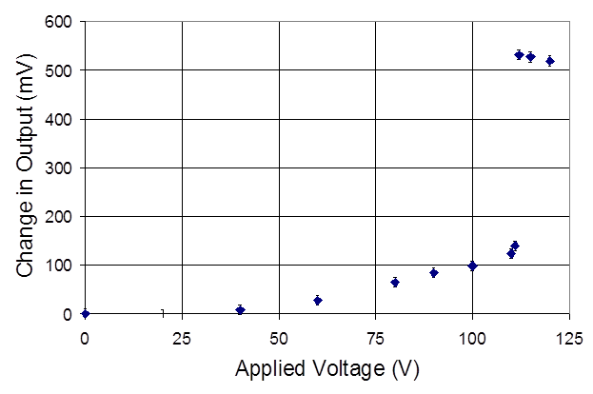
Figure 4. Fiber-optic signal as a function of applied DC voltage for sensor in operation position.
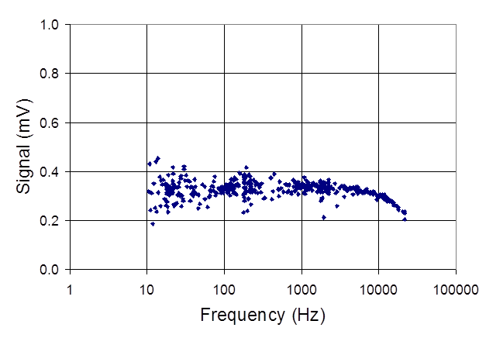Figure 5. Frequency scan with input amplitude at 16.67 V

For comparison, the structure was also studied on a Polytec PI Microscanning Vibrometer (MSV). This is a powerful tool that enables a variety of measurements, including mode visualization and high-resolution deflection measurement. Using the MSV, the deflection at the center of the beam was measured against applied voltage at an excitation frequency of 2 kHz, which results in a deflection signal at 4 kHz due to the dependence of deflection on the square of the applied voltage. The same experiment was conducted on the fiber optic system. The results, shown in Fig. 6, compare favorably in the range of 1-7 V, indicating that the fiber-optic-based system can be used for quantitative deflection measurement. The MSV system was limited to about 7 V rms in applied voltage magnitude. The substitution of an additional function generator would extend the range of the MSV.
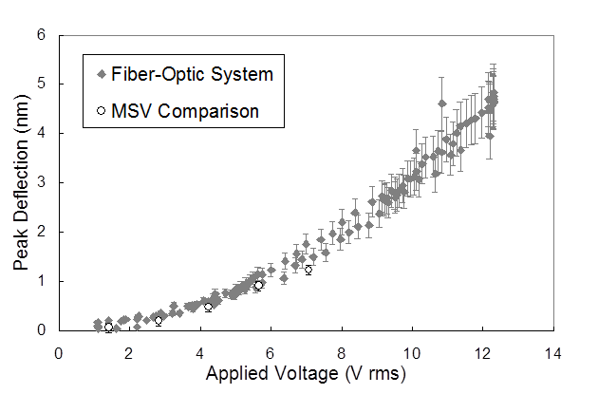
Figure 6. Comparison between the voltage-deflection characteristic of the fiber optic system and the MSV at 4 kHz. Use error bars! Try to make realistic estimates of your system’s error.

In order to verify our system over a larger deflection range, the calibrated pull-in characteristic obtained with the fiber-optic system was compared to that obtained using a Wyko NT1100 Optical Profiler. The results are shown in Fig. 7. The two systems agree within the resolution of the Wyko, which is about 0.2 μm.
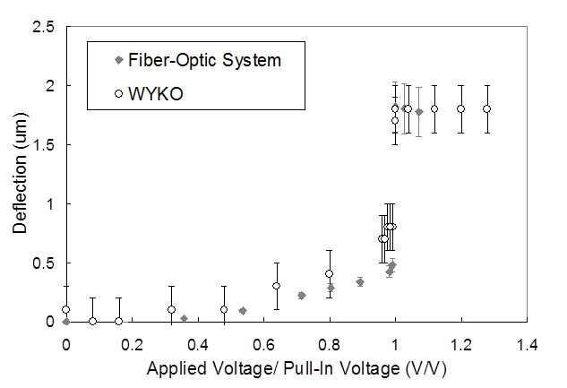
Figure 7. Comparison of voltage-deflection characteristic obtained with fiber optic system and that measured with the optical profilometer (both measurements conducted at DC). Note the error bars!!!

Other Format Notes
(This is not a section that should appear in your report) Please take note of the following items when proofreading spelling and grammar.

Abbreviations and Acronyms
Define abbreviations and acronyms the first time they are used in the text, even after they have been defined in the abstract. Abbreviations such as IEEE and SI do not have to be defined. Do not use abbreviations in the title or heads unless they are unavoidable.

Units
- Use SI as primary units. (SI units are encouraged.) English units may be used as secondary units (in parentheses). An exception would be the use of English units as identifiers in trade, such as “3.5-inch disk drive”.
- Do not mix complete spellings and abbreviations of units: “Wb/m²” or “webers per square meter”, not “webers/m²”. Spell out units when they appear in text: “. . . a few henries”, not “. . . a few H”.
- Use a zero before decimal points: “0.25”, not “.25”. Use “cm³”, not “cc”.

Equations
The equations are an exception to the prescribed specifications of this template. You will need to determine whether or not your equation should be typed using either the Times New Roman or the Symbol font (please no other font). To create multileveled equations, it may be necessary to use the Microsoft equation editor.
Number equations consecutively. Equation numbers, within parentheses, are to position flush right, as in Eq. 1, using a right tab stop. To make your equations more compact, you may use the solidus ( / ), the exp function, or appropriate exponents. Italicize Roman symbols for quantities and variables, but not Greek symbols. Use a long dash rather than a hyphen for a minus sign. Punctuate equations with commas or periods when they are part of a sentence, as in
       
Note that the equation is centered using a center tab stop. Be sure that the symbols in your equation have been defined before or immediately following the equation. Use “Eq. 1” or “Equation 1”, not “(1)”, especially at the beginning of a sentence: “Equation 1 is . . .”

Figures and Tables
Large figures and tables may span across both columns. Figure captions should be below the figures; table captions should appear above the tables. Insert figures and tables after they are cited in the text. Use the abbreviation “Fig. 1” in the text, and “Figure 1” at the beginning of a sentence.
Use 8 point Times New Roman for figure labels. Use words rather than symbols or abbreviations when writing figure-axis labels to avoid confusing the reader. As an example, write the quantity “Magnetization”, or “Magnetization, M”, not just “M”.
If including units in the label, present them within parentheses. Do not label axes only with units. In the example, write “Magnetization (A/m)”, not just “A/m”.
- Table Type Styles
Table Head | Table Column Head
 | Table column subhead | Subhead | Subhead
copy | More table copyª

Some Common Mistakes
- The word “data” is plural, not singular.
- The subscript for the permeability of vacuum μ₀, and other common scientific constants, is zero with subscript formatting, not a lowercase letter “o”.
- In American English, commas, semi-/colons, periods, question and exclamation marks are located within quotation marks only when a complete thought or name is cited, such as a title or full quotation. When quotation marks are used, instead of a bold or italic typeface, to highlight a word or phrase, punctuation should appear outside of the quotation marks. A parenthetical phrase or statement at the end of a sentence is punctuated outside of the closing parenthesis (like this). (A parenthetical sentence is punctuated within the parentheses.)
- A graph within a graph is an “inset”, not an “insert”. The word alternatively is preferred to the word “alternately” (unless you really mean something that alternates).
- Do not use the word “essentially” to mean “approximately” or “effectively”.
- In your paper title, if the words “that uses” can accurately replace the word “using”, capitalize the “u”; if not, keep using lower-cased.
- Be aware of the different meanings of the homophones “affect” and “effect”, “complement” and “compliment”, “discreet” and “discrete”, “principal” and “principle”.
- Do not confuse “imply” and “infer”.
- The prefix “non” is not a word; it should be joined to the word it modifies, usually without a hyphen.
- There is no period after the “et” in the Latin abbreviation “et al.”.
- The abbreviation “i.e.” means “that is”, and the abbreviation “e.g.” means “for example”.

Conclusion
(Now back to our example—always have a conclusion where you sum up what you did with the work). It has been shown how the fiber optic displacement sensor system, which is at least an order of magnitude less expensive than the microscanning vibrometer system, and about five times less expensive than the optical profiler, can be used to obtain quantitative pull-in and deflection information for a system whose behavior is reasonably well understood, and to obtain frequency response data over a somewhat limited range (fiber optic sensor units are available up to 200 kHz). The technique is unobtrusive, and only places the constraint of requiring the device to be optically accessible. While the system lacks the broad bandwidth, lateral resolution and mode visualization capabilities of commercial systems, the low-cost, quick set-up time and flexibility of this fiber optic system make it a potentially valuable tool for a small research group.

References
(List and number any bibliographical references in 9-point Times, single-spaced, at the end of your paper. When referenced in the text, enclose the citation number in square brackets, for example: [1].)

- J. J. Yao, "RF MEMS from a device perspective," J. Micromech. Microeng., vol. 10, pp. R9-R38, 2000.
- E. R. Brown, "RF-MEMS switches for reconfigurable integrated circuits," IEEE Trans. Microw. Theory Tech., vol. 46, pp. 1868-1880, 1998.
- M. Kim, J. B. Hacker, R. E. Mihailovich, and J. F. DeNatale, "A DC-to-40 GHz four-bit RF MEMS true-time delay network," IEEE Microw. Wirel. Comp. Lett., vol. 11, pp. 56-58, 2001.
- A. Malczewski, S. Eshelman, B. Pillans, J. Ehmke, and C. L. Goldsmith, "X-band RF MEMS phase shifters for phased array applications," IEEE Microw. Guided Wave Lett., vol. 9, pp. 517-519, 1999.
- D. J. Bishop, C. R. Giles, and G. P. Austin, "The Lucent LambdaRouter: MEMS technology of the future here today," IEEE Comm. Mag., pp. 75-79, 2002.
- P. B. Chu, S.-S. Lee, and S. Park, "MEMS: The path to large optical crossconnects," IEEE Comm. Mag., pp. 80-87, 2002.
- P. De Dobbelaere, K. Falta, L. Fan, S. Gloeckner, and S. Patra, "Digital MEMS for optical switching," IEEE Comm. Mag., pp. 88-95, 2002.
- P. R. Scheeper, A. G. H. v. d. Donk, W. Olthuis, and P. Bergveld, "A review of silicon microphones," Sens. & Act. A, vol. 44, pp. 1-11, 1994.
- N. Yazdi, F. Ayazi, and K. Najafi, "Micromachined inertial sensors," Proc. IEEE, vol. 86, pp. 1640-1659, 1998.
- J. T. Kung, H.-S. Lee, and R. T. Howe, "A digital readout technique for capacitive sensor applications," IEEE J. Solid-State Circuits, vol. 23, pp. 972-977, 1988.
- S. Ranganathan, M. Inerfield, S. Row, and S. L. Garverick, "Sub-femtofarad capacitive sensing for microfabricated transducers using correlated double sampling and delta modulation," IEEE Trans. Circuits & Systems-II: Analog and Digital Signal Processing, vol. 47, pp. 1170-1176, 2000.
- A. Selvakumar and K. Najafi, "A high-sensitivity z-axis capacitive silicon microaccelerometer with a torsional suspension," J. Microelectromech. Syst., vol. 7, pp. 192-200, 1998.
- J. A. Harley and T. W. Kenny, "1/f noise considerations for the design and process optimization of piezoresistive cantilevers," J. Microelectromech. Syst., vol. 9, pp. 226-235, 2000.
- J. D. Hall, N. E. Apperson, B. T. Crozier, C. Xu, R. F. Richards, D. F. Bahr, and C. D. Richards, "A facility for characterizing the dynamic mechanical behavior of thin membranes for microelectromechanical systems," Rev. Sci. Instrum., vol. 73, pp. 2067-2072, 2002.
- R. Schnitzer, N. Rümmler, V. Großer, and B. Michel, "Vibration measurement of microstructures by means of laseroptical modal analysis," presented at EUROPTO Conference on Microsystems Metrology and Inspection, Munich, Germany, 1999.
- A. Bosseboeuf, J. P. Gilles, K. Danaie, R. Yahiaoui, M. Dupeux, J. P. Puissant, A. Chabrier, F. Fort, and P. Coste, "A versatile microscopic profilometer-vibrometer for static and dynamic characterization of micromechanical devices," presented at EUROPTO Conference on Microsystems Metrology and Inspection, Munich, Germany, 1999.
- C. J. Tay, C. Quan, H. Wang, H. M. Shang, and K. C. Chan, "Measurement of a microphone membrane deflection profile using an optical fibre and wedge fringe projection," Meas. Sci. Technol., vol. 12, pp. 320-326, 2001.
- K. A. Honer, N. I. Maluf, E. Martinez, and G. T. A. Kovacs, "Characterizing deflectable microstructures via a high-resolution laser-based measurement system," Sens. & Act. A, vol. 52, pp. 12-17, 1996.
- D. F. L. Jenkins, M. J. Cunningham, W. W. Clegge, and M. M. Bakush, "Measurement of the modal shapes of inhomogeneous cantilevers using optical beam deflection," Meas. Sci. Technol., vol. 6, pp. 160-166, 1995.
- Y. Nemirovsky and O. Bochobza-Degani, "A methodology and model for the pull-in parameters of electrostatic actuators," J. Micromech. Syst., vol. 10, pp. 601-615, 2001.
- F. Yang, "Electromechanical instability of microscale structures," J. Appl. Phys., vol. 92, pp. 2789-2794, 2002.
- J. Wibbeler, G. Pfeifer, and M. Hietschold, "Parasitic charging of dielectric surfaces in capacitive microelectromechanical systems (MEMS)," Sens. & Act. A, vol. 71, pp. 74-80, 1998.
- J. R. Reid, R. T. Webster, and L. A. Starman, "Noncontact measurement of charge induced voltage shift in capacitive MEM-switches," IEEE Microw. Wirel. Comp. Lett., vol. 13, pp. 367-369, 2003.
- E. K. Chan, K. Garikipati, and R. W. Dutton, "Characterizationi of contact electromechanics through capacitance-voltage measurements and simulations," J. Microelectromech. Syst., vol. 8, pp. 208-217, 1999.
- E. Cretu, L. A. Rocha, and R. F. Wolffenbuttel, "Micromechanical voltage reference using the pull-in of a beam," IEEE Trans. Instrum. Meas., vol. 50, pp. 1504-1507, 2001.
- R. F. Wolffenbuttel and C. J. van Mullem, "The relationship between microsystem technology and metrology," IEEE Trans. Instrum. Meas., vol. 30, pp. 1469-1474, 2001.
- P. M. Osterberg and S. D. Senturia, "M-TEST: A test chip for MEMS material property measurement using electrostatically actuated test structures," J. Micromech. Syst., vol. 6, pp. 107-118, 1997.

