Date: Saturday, 12 NOV 2016, 0800 start time
Event: Rosaryville Veterans Day 50k
Distance: 50K
Location: Upper Marlboro
Weather: high 30s, 40s, and 50s
Participants: 24 Midshipmen
14 Runners
10 Volunteers
0 USNA Representatives

Summary:
The Navy Marathon team traveled to Rosaryville, MD in order to compete in the Rosaryville Veterans Day 50K. The team met up at 0450 the morning of the race in order to take the bus to drive over to Rosaryville. The race took place in Rosaryville State Park in the deep woods. The course has rolling hills, and is shaded by colorful trees. This was a great race and a fun way to end the team’s season with, however, due to the rough terrain and length, it was blessing it came at the end of the season. On the positive side; this terrain also helped the team develop certain running muscles further. The Midshipmen enjoyed the cool weather as they pushed one another in groups, and had many strong finishes and great volunteers.

This was most of the runners on the team’s first ultra marathon, opening the team’s knowledge to new lengths. There were also a few plebe volunteers whose first experience with the marathon team was at this event and a positive time. The volunteers were all able to enjoy a ten mile loop in the middle of the race.

Notable finishers included:
Overall Winner - Charles Oestreich

Males Age Group Awards-
Jack Huntress - 1st (20 to 29 male)
Noah Miller - 1st (1 to 19 Male)

Female Age Group awards-
Sara Jenkins- 1st (20 to 29 Female)

Results (Men)

Name | Finish Time | Overall Place (out of 117) | Place in age group | Awards
Charles Oestreich | 3:36 | 1 | n/a | Race Winner and  7th best time all time for course
Jack Huntress | 4:06 | 4 | 1 of 8 (20-29) | Age Gp Winner
Noah Miller | 4:18 | 8 | 1 of 2 (1-19) | Age Gp Winner
Jacob, Cuningham | 4:40 | 17 | 3 of 8 (20-29)
Thomas Henson | 5:15 | 30 | 4 of 8 (20-29)
Trevor Karn | 5:15 | 32 | 5 of 8(20-29)
Wayne Sommerlot | 5:28 | 38 | 2 of 2 (20-29)
Jared, Haley | DNF | n/a | n/a
Garrett Yu | DNF | n/a | n/a

Results (Female)

Name | Finish Time | Overall Place (out of 117) | Place in age group | Awards
Sara Jenkins | 5:15 | 31 | 1 of 5 (20-29) | Age Gp Winner
Alexis Opferman | 5:15 | 29 | n/a | Veteran Female
Marissa Reynolds | 6:12 | 65 | 2 of 5

To conclude, the ten volunteers helped out in numerous ways such as: unloading the truck of food, pre-registration, first aid, starting line materials, acting as parking lot directors, aid stop workers, aid stop runners, finish line ticketers, sweepers of the course, and tear down team. The course was a three-loop course consisting of 9.8-miles around the trail’s perimeter. The Annapolis Striders presented the race.

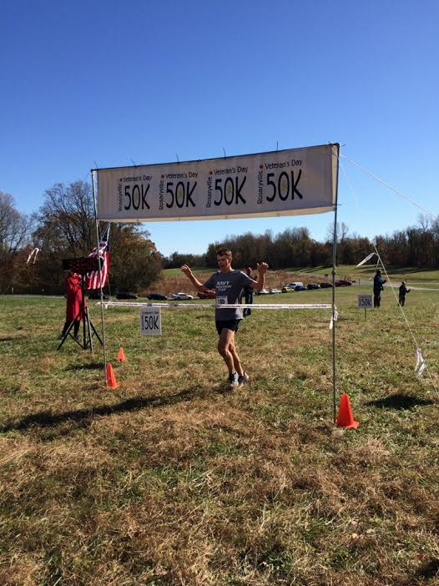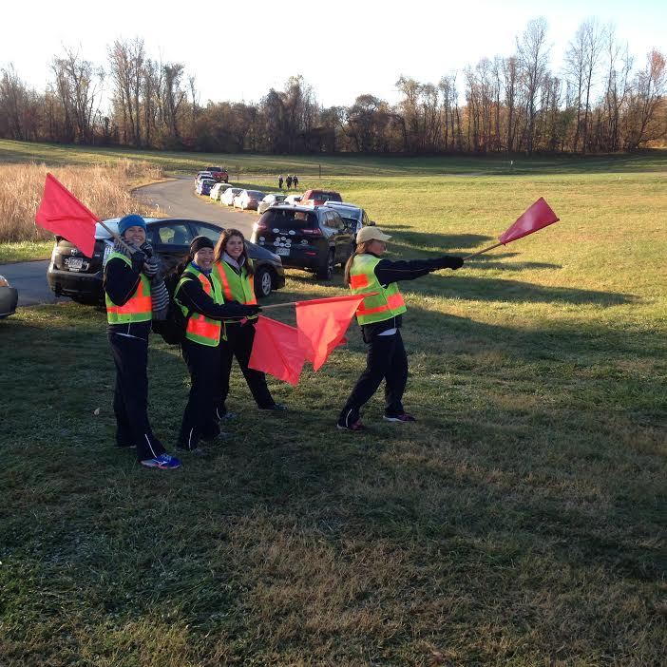
USNA First Place Finisher- Charles Oestreich Parking Lot Directors- Kelly Frantz, Kendal Good,
Amanda Cestone, and Holly Sandler
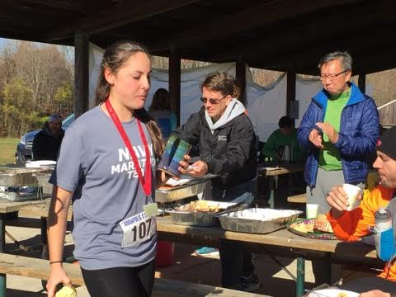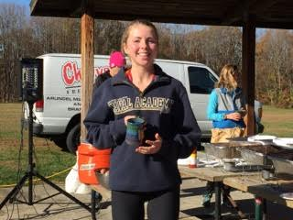
USNA’s Alexis Opferman receiving USNA’s Sara Jenkins receiving the first place age the Military Award group award from 20 to 29
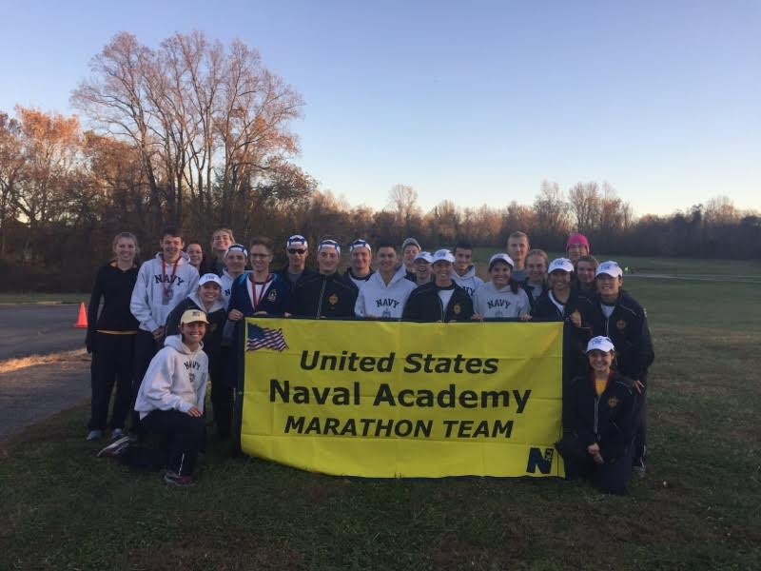
The Race Director and The United States Naval Academy Marathon Team after the race- Alexis Opferman, Sara Jenkins, Marissa Reynolds, Garrett Yu, Wayne Sommerlot, Charles Oestreich, Noah Miller, Trevor Karn, Jack Huntress, Thomas Henson, Jared Haley, Jacob Cunningham, Raymond Sutschek, Kathia Castaneda, Amanda Cestrone, Cathryn DeLong, Claire Eckhardt, Kelly Frantz, Kendal Good, Sydney Hirokawa, Julia McFarland, Holly Sandler and Thomas DeKornfeld (Race Director)

