United States Naval Academy Marathon Team
Date: 03 September 2016 (0500 – 1100)
Coach: Nate Nudelman
O-REP: LCDR Casey Rayburg
Event: Charles Street 12 Mile Race
Location: Baltimore, MD
Weather: Approx. 78 degrees, overcast skies
Participants: 31 Midshipmen, 1 Coach, 1 Officer Representative
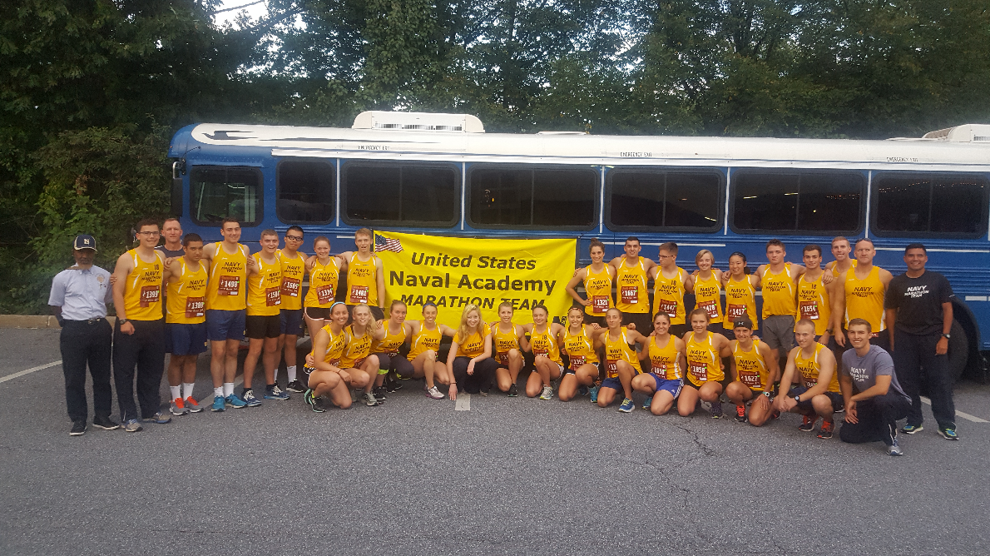
Race Background:
The Charles Street 12 is a twelve mile race that takes runners through Baltimore’s historic district. The race is an annual event, bringing together runners of all backgrounds to compete, socialize, and enjoy their Saturday morning Labor Day Weekend. Beginning in Towson, Maryland, at the Shops at Kenilworth, the course stretches twelve miles spanning North to South as competitors tackle long straightaways and grueling hills until their journey concludes at Power Plant Live! in downtown Baltimore.
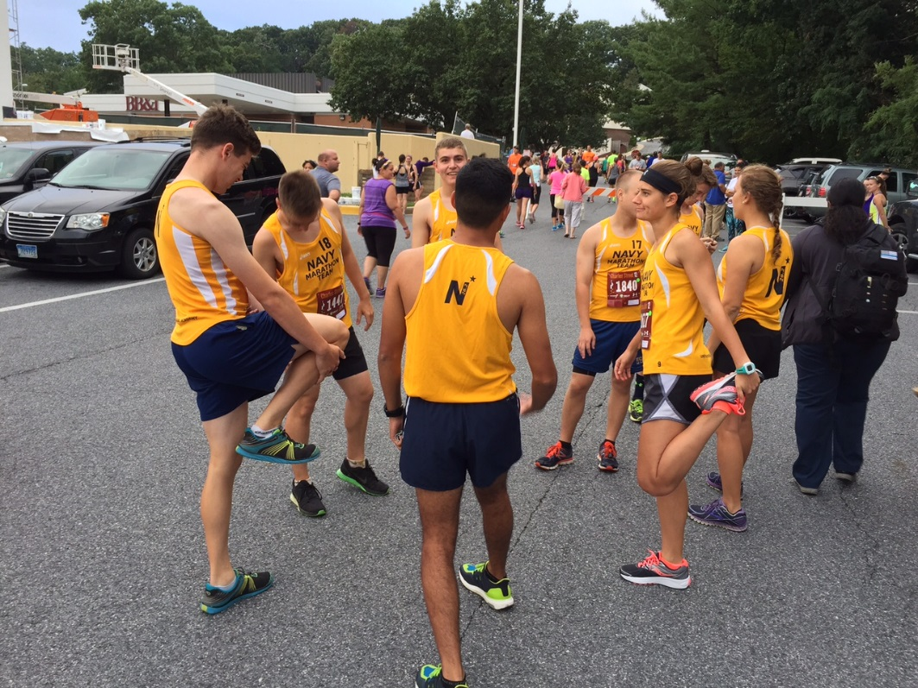
Race Warm Up

On Race Day:
On 3 September, 2016, the United States Naval Academy Marathon Team traveled from USNA to Baltimore to compete in this incredible event. This race was particularly special for the team, as the participant turnout was very high and allowed for the team to travel together to compete. After loading onto the bus at 0500, the team departed USNA and arrived at Towson at 0545 where it conducted packet pick-up. Pre-race photos were taken, and the team moved to the start line, taking its place at the front of the pack. The air horn sounded, and within two hours the entire team had finished the grueling twelve mile race.

Results:
The USNA marathon team performed exceptionally well at the Charles Street 12. Three runners won medals and several others finished in the top twenty-five overall. The winner of the Charles Street 12 was a former USNA marathon team runner, Jordan Tropf, a graduate of the USNA Class of 2014. A list of the team results are below.

Male Runners
LAST | FIRST | FINISH TIME
Palladino | Christopher | 1:12:20.0  6th Overall, 1st in Age Group
Zepeda | Kurt | 1:13:45.8  10th Overall, 2nd in Age Group
Davidson | Tyler | 1:14:11.0  12th Overall, 3rd in Age Group
Keating | Connor | 1:15:08.8  15th Overall, 4th in Age Group
Larios | Gabriel | 1:15:10.3  16th Overall, 5th in Age Group
Henson | Thomas | 1:21:44.2
Siprelle | Samuel | 1:21:55.0
Jensen | Dylan | 1:22:22.4
Ward | Stephen | 1:23:08.7
Gasper | Jack | 1:23:47.7
Perez | Salvador | 1:27:38.7
Follett | Eduardo | 1:32:19.6
Peng | George | 1:44:48.3

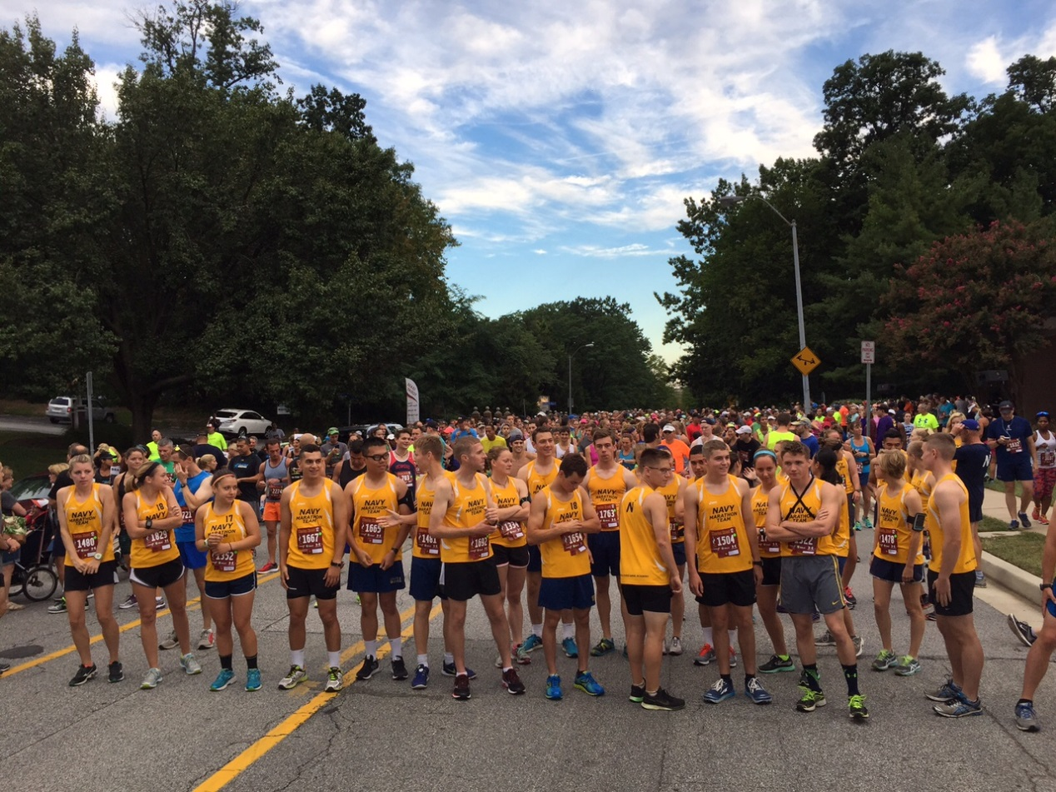
At The Start Line
LAST | FIRST | FINISH TIME
Dooley | Cassandra | 1:17:13.5  26th Overall, 2nd in Age Group
Moynihan | Kaitlan | 1:18:55.9  32nd Overall, 3rd in Age Group
Vernon | Caitlyn | 1:33:58.0
Jenkins | Sara | 1:33:58.0
Opferman | Alexis | 1:37:30.1
Wible | Rachel | 1:37:30.4
Dods | Margaret | 1:40:01.7
Sandler | Holly | 1:46:30.0
Frantz | Kelly | 1:46:30.8
Good | Kendal | 1:46:34.3
Perdew | Abigail | 1:47:43.7
Daitz | Kylee | 1:50:07.7
Schilder | Elizabeth | 1:52:13.3
Female Runners

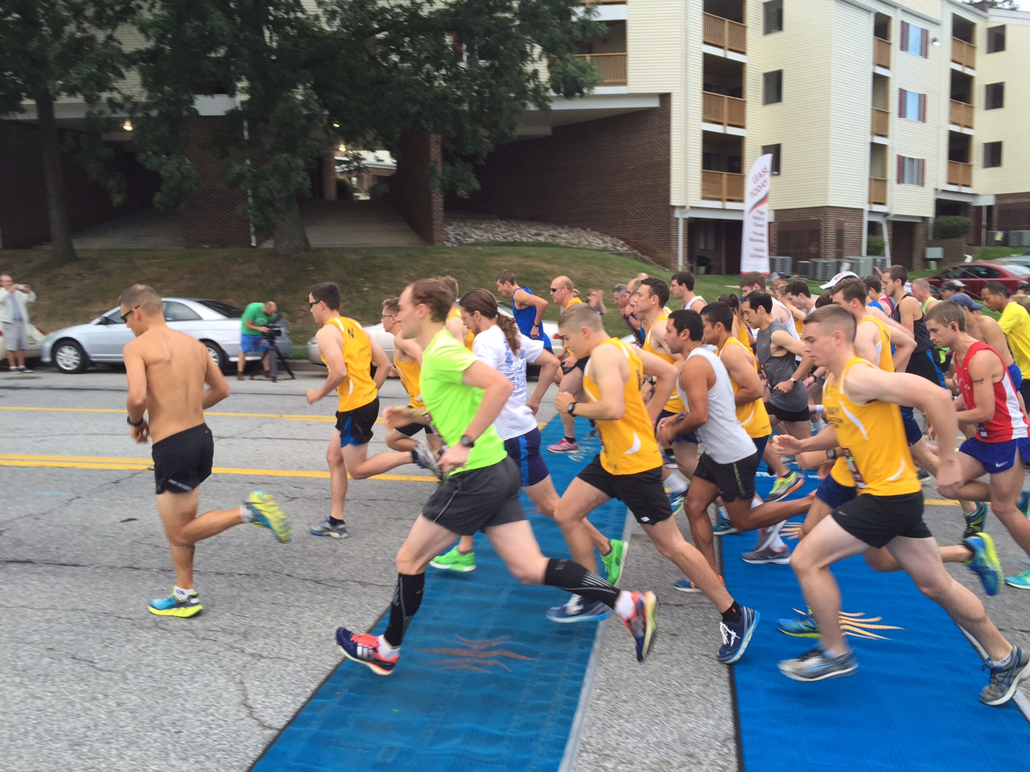
Start of Race
Coach & LCDR
LAST | FIRST | FINISH TIME
Rayburg | Casey | 1:18:55.1
Nudelman | Nathan | 1:22:18.8

Volunteers
LAST | FIRST
Parrish | Jackson
Rose | Hannah

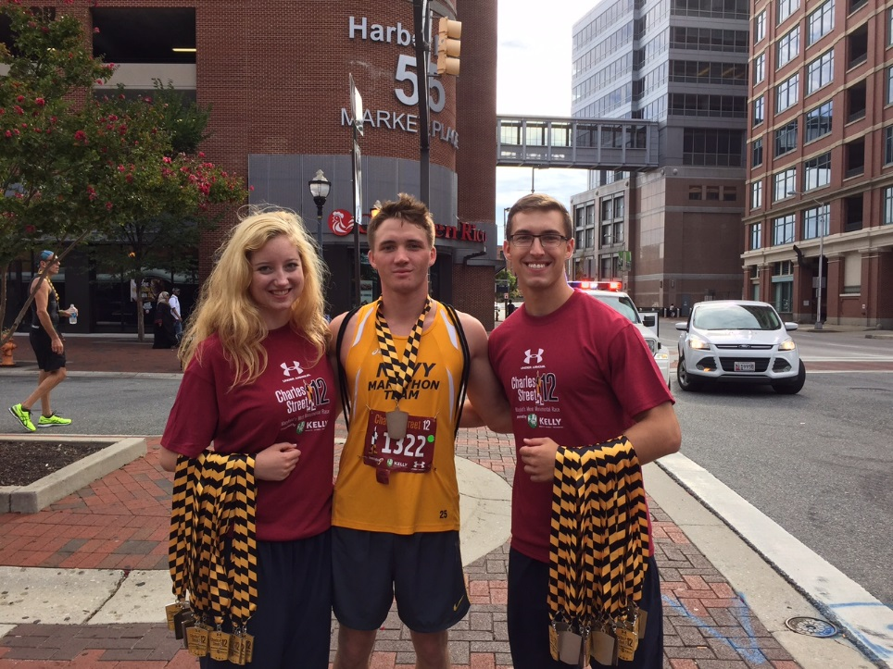
Volunteering At Race Finish Line (handing out medals)

Course Information:
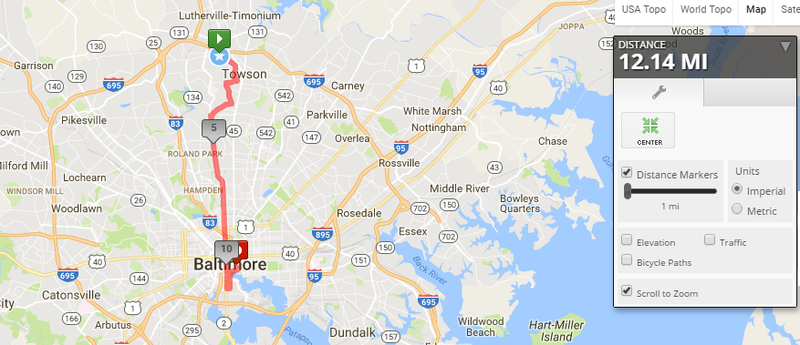
This is a 12.14 mi Run in Towson, MD, United States. The Run has a total ascent of 396.23 ft and has a maximum elevation of 489.6 ft.
Source: Mapmyrun.com:
http://www.mapmyrun.com/us/lutherville-md/charles-street-12-official-route-205375476

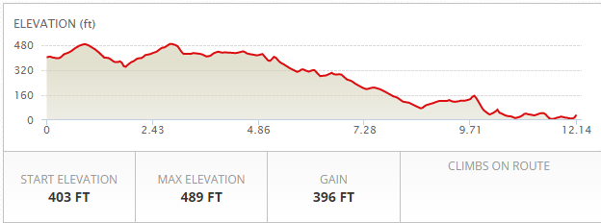

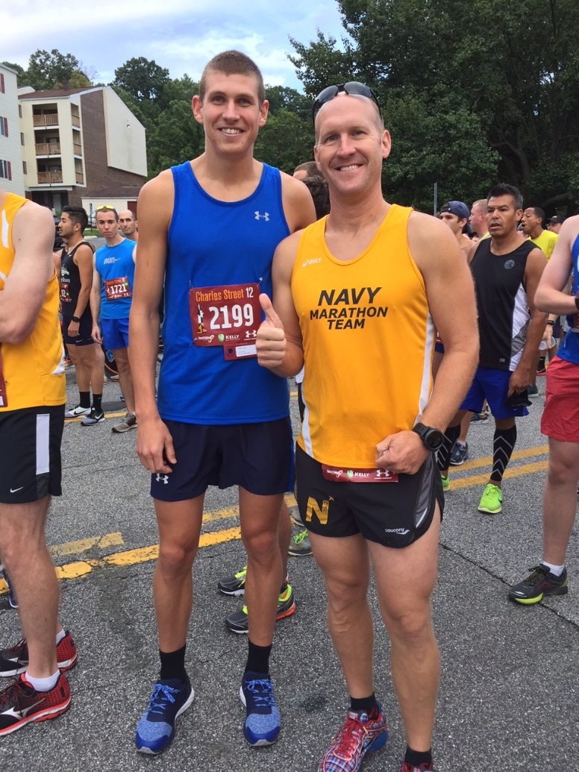
Coach Nate Nudelman with former USNA Marathon Team member Jordan Tropf
(winner of the Charles Street 12)

After Action Report Created By MIDN 2/C Jackson Parrish, Race POC

