United States Naval Academy
Marathon Team

Date: Sunday, 08 April 2018, 0730 start time
Event: B&A Marathon and Half Marathon
Distance: 13.1 miles/26.2 miles
Location: Severna Park, MD
Weather: Scattered clouds and sunshine, mild wind, around 38 degrees Fahrenheit
Participants: 23 Runners (12 full marathon runners and 11 half marathon runners)
14 Volunteers
2 USNA Representatives – OREP- Major Covington and Coach Nathan Nudelman

Summary:
The Navy Marathon team traveled to Severna Park, Maryland in order to compete in the annual B&A Marathon and Half Marathon. The team met at 0545 on Sunday (08 APR 2018) to drive to Severna Park high school where the race was being held. The bus left at 0610 and the team arrived at the high school at 0630, where the team dropped off their bags, stretched, and mentally prepared for the race ahead. The race took off at 0730, with twelve midshipmen running the full marathon and eleven midshipmen ran the half marathon. Twelve volunteers represented the team by supporting the Annapolis running community by helping set up the course, hand out water at aid stations, and direct runners in the cold temperature. The team sent six volunteers at 0545 to set up the start and finish lines and other tasks before the race started so that it would run smoothly. Following the conclusion of the races, the team ate, drank, and stretched as they listened to the awards ceremony. MIDN 2/C Jack Huntress won the half marathon with a time of 1:16:57 and MIDN 4/C Raul Castillo placed third with a time of 1:21:23. MIDN 4/C Elizabeth Farnan qualified for the 2019 Boston Marathon with a time of 3:30:07. The team left to head back to USNA at 1230 and arrived around 1300.

Results:
Full Marathon Runners
Name(Last, First) | Gender | Time | Comments
Tegtmeyer, David | Male | 3:27:17 | First marathon
Brown, Jamel | Male | 3:55:24
Higgins, Jack | Male | 3:59:30 | First marathon
Karn, Trevor | Male | DNF
Moriarty, Daniel | Male | DNF
Farnan, Elizabeth | Female | 3:30:07 | 2019 Boston Qualifier
Phillips, Alana | Female | 3:44:25
Doyle, Emily | Female | 3:47:10
Gibson, Annie Laurie | Female | 3:47:10
Good, Kendal | Female | 4:02:56
Maguire, Jamie | Female | 4:02:56
McGinnis, Jordan | Female | 4:05:03
Coach Nathan Nudelman | Male | 4:01:45 | 91st marathon!

Half Marathon Runners
Name(Last, First) | Gender | Time | Comments
Huntress, Jack | Male | 1:16:57 | Placed first overall and was his first half marathon
Castillo, Raul | Male | 1:21:23 | Placed third overall
Harper, Cullen | Male | 1:31:44
Perez, Salvador | Male | 1:32:32
Sosa, Jocelyn | Female | 1:39:17
McDonnell, Lauren | Female | 1:42:25 | First half marathon
O'Neil, Madeleine | Female | 1:43:54
Lemek, Natalie | Female | 1:53:47
McKeon, Shannon | Female | 1:53:47 | First half marathon
MacDonald, Julia | Female | 1:55:00
Eckhardt, Claire | Female | 1:58:57
Major James Covington | Male | 1:57:01 | O-Rep

Volunteers
Name (Last, First)
Carrillo, Victor
Dooley, Cassandra
Fish, Brendan
Gooding, Katherine
Jenkins, Sara
Keating, Conor
Kim, Victor
Lane, Grace
Oestreich, Charles
Roberts, August
Robinson, Cara
Roxbury, Niki
Walsh, Svetla
Yu, Garrett

Photos:

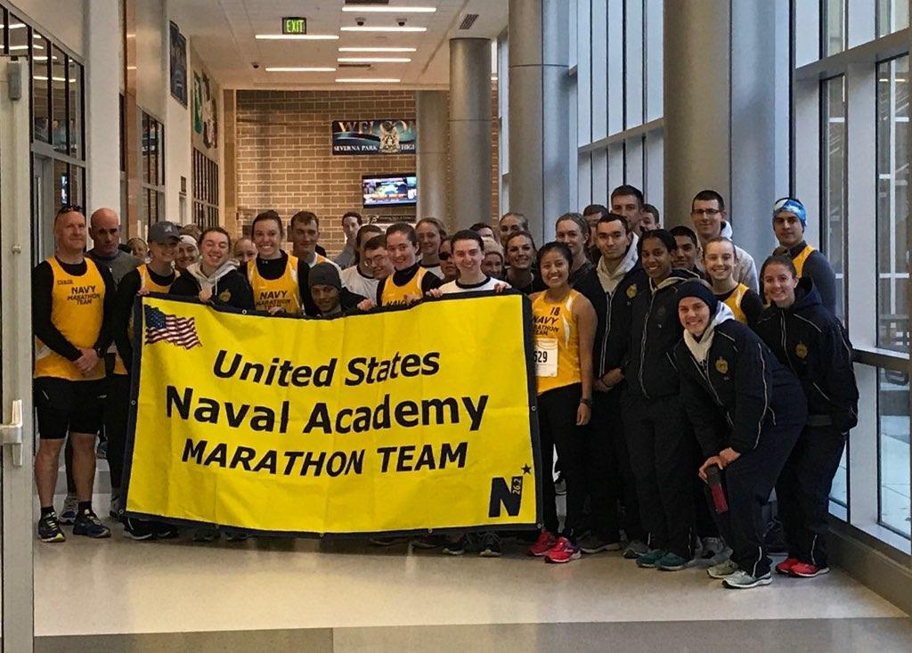
The team starts out the day with a pre-race team picture!

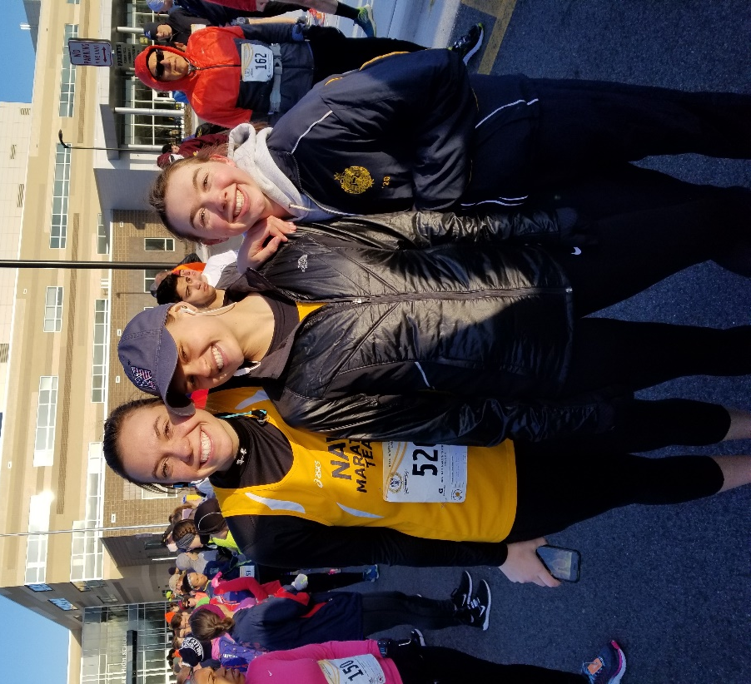
From left to right: MIDN O’Neil, Phillips, and McFarland pose at the start line
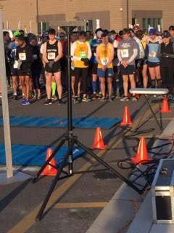
The men’s team waits for the gun to go off and start the race!
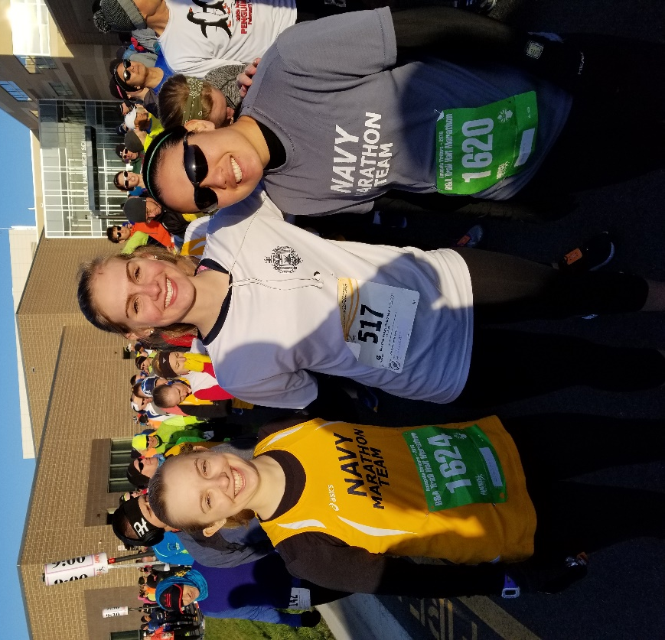
From left to right: MIDN Maguire, Eckhardt, and Good pose at the start line

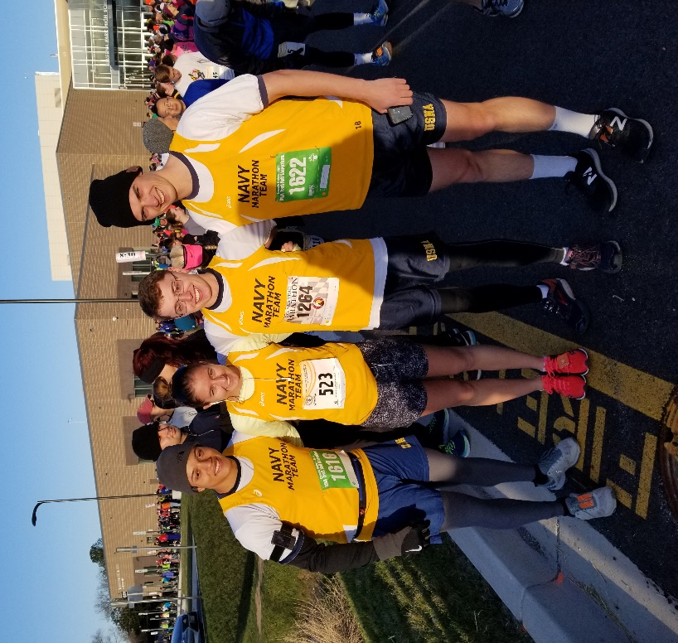
From left to right: MIDN Brown, MacDonald, Tegtmeyer, and Higgins pose at the start line
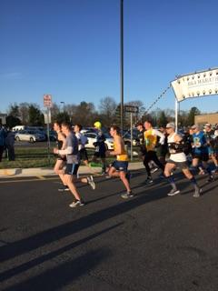
The men’s team takes off as the race begins!

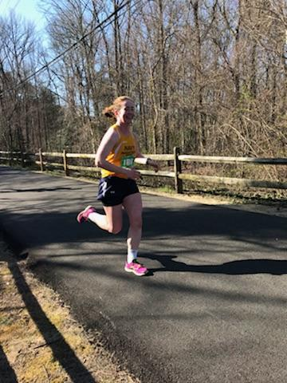
MIDN Farnan powers through and qualifies for the 2019 Boston Marathon!

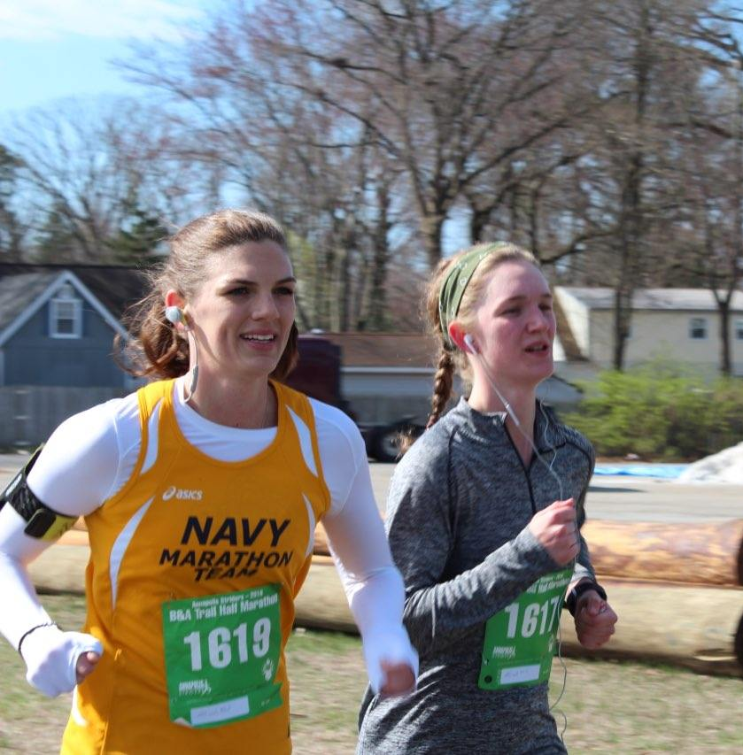
From left to right: MIDN Gibson and Doyle cruise through the marathon

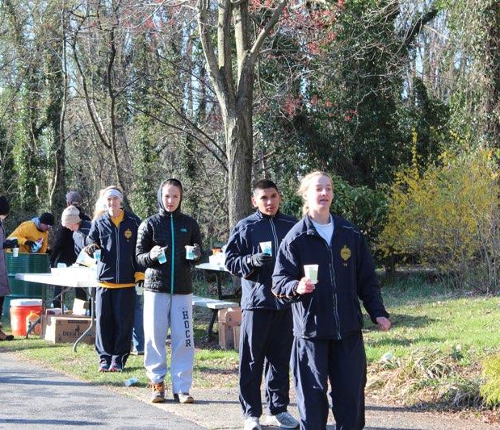
Volunteers from the team hand out water and Gatorade at an aid station

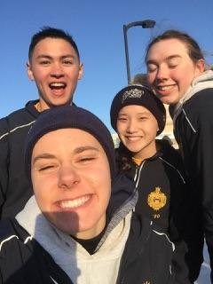
Our volunteers take a quick picture after working hard directing runners through the course. From left to right: MIDN Yu, Lane, Roxbury, and McFarland

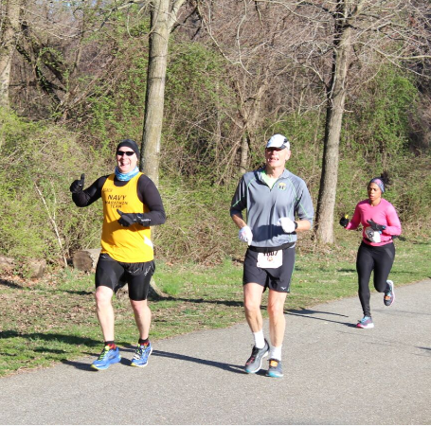
Coach Nathan Nudelman smiles as he powers through his 91st marathon

Conclusion: Overall, the race was extremely successful with a 1st and 3rd place overall finisher, a Boston qualifier, and five midshipmen who completed their first full or half marathon. The volunteers braved the cold and helped out the Annapolis running community all day with a smile on their faces.

After Action Report Prepared by: MIDN 2/C Maguire

