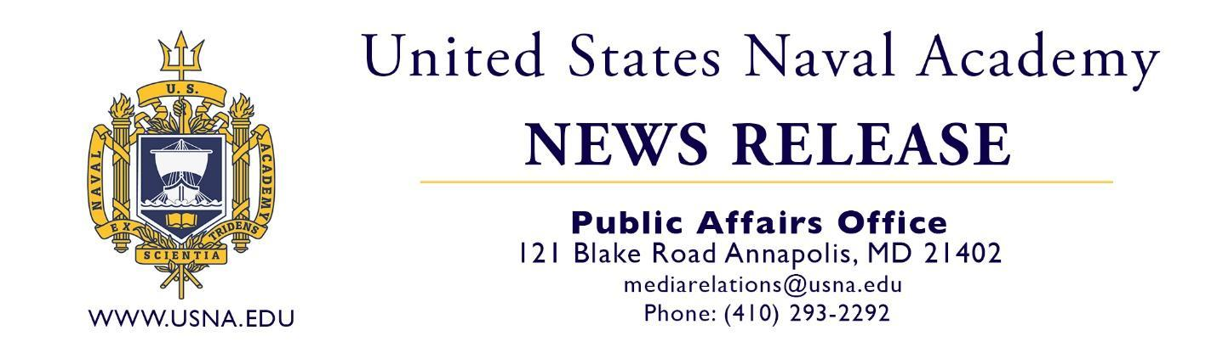

MEDIA CONTACTS: Elizabeth Wrightson, Colleen Krueger, Kamilah Bryant
PAO: Cmdr. Ashley Hockycko
1 Month Day, Year
FOR IMMEDIATE RELEASE

NOTE to Editors and Reporters: Please contact the person submitting this release for additional information about or a portrait photo of the graduate. Please contact the Naval Academy Public Affairs Office for any questions about the academy.

2_____ NATIVE GRADUATES FROM THE U.S. NAVAL ACADEMY

ANNAPOLIS, Md. – 3_____ of 4____, 5_____ successfully completed four years of challenging academic, physical, and professional military training, graduating from the United States Naval Academy with a Bachelor of Science degree in 6______ and a commission as a 7______________. 8_____ is a graduate of 9________. At the academy, 10_____ was a member of the 11__________.

Founded in 1845, the U.S. Naval Academy today is a prestigious four-year service academy that prepares midshipmen morally, mentally and physically to be professional officers in the naval service. More than 4,400 men and women representing every state in the U.S. and several foreign countries make up the student body, known as the Brigade of Midshipmen. U.S. News and World Reports has recognized the Naval Academy as the 2025 #1 public school and #3 best liberal arts college. Midshipmen learn from military and civilian instructors and participate in intercollegiate varsity sports and extracurricular activities. They also study subjects such as leadership, ethics, small arms, drill, seamanship and navigation, tactics, naval engineering and weapons, and military law. Upon graduation, midshipmen earn a Bachelor of Science degree in a choice of 26 different subject majors and go on to serve at least five years of exciting and rewarding service as commissioned officers in the U.S. Navy or U.S. Marine Corps.

The Brigade of Midshipmen is comprised of approximately 4,400 students from every state in the union. Each year, about 1,200 students are admitted to the Naval Academy’s incoming class.

The academy’s alumni include, one president, 32 members of Congress, six governors, 72 Medal of Honor recipients, two Nobel Prize winners, 56 astronauts, 56 Rhodes Scholars, and over 4,000 admirals and generals.
USNA

