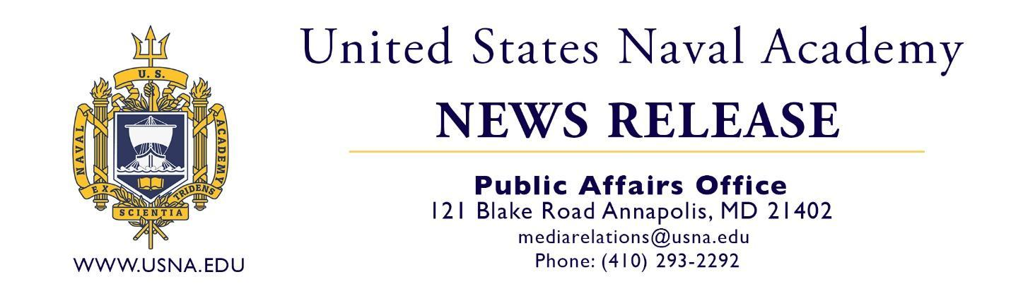

INSTRUCTIONS FOR USING THE GRADUATION PRESS RELEASE

You may email, mail, fax, or hand deliver the completed release to your local newspapers. Be sure to include your contact info before you submit it. Note that this release is written in the appropriate style with correct abbreviations used by the media. Please do not make changes to the release beyond the information below.

Fill in the blanks on the enclosed release with the appropriate information:
- Date of release
- Hometown
- Name – first, then last
- City
- State
- Degree
- 2nd Lieutenant in the United States Marines OR Ensign in the United States Navy
- Last name
- High school name and city
- Last name
- Sports, clubs, company, or any other pertinent achievement

For the proper way to abbreviate your state in media style, see the list below. If your state is not listed below, it should not be abbreviated.

Ala. | Kan. | Nev. | S.C.
Ariz. | Ky. | N.H. | S.D.
Ark. | La. | N.J. | Tenn.
Calif. | Md. | N.M. | Tx.
Colo. | Mass. | N.Y. | Vt.
Conn. | Mich. | N.C. | Va.
Del. | Minn. | N.D. | Wash.
Fla. | Miss. | Okla. | W.Va.
Ga. | Mo. | Ore. | Wis.
Ill. | Mont. | Pa. | Wyo.
Ind. | Neb. | R.I.

If you have questions regarding this release, email pao@usna.edu.

