Squad Leader Handbook

2019-2020

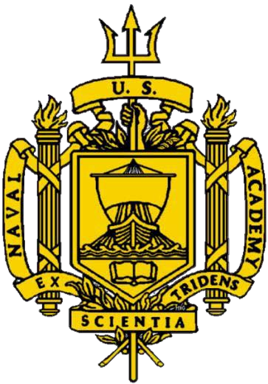

Squad Leaders: The Backbone of the Brigade

Table of Contents

Commandant’s Intent 2
Brigade Commander’s Intent Spring 2020 3
A Word from the Brigade Honor Advisor 4
Training Officer Input 5
The Role of a Squad Leader 6
Advice from Squad Leaders 8
Resources to Address Challenges Within the Squad 11
How to Plan a Squad Event 13
Squad Activities 16
References 21
Weekly Update Sheet 22
Individual Development Plan 23
Midshipman Counseling Form (Form 1) 24
Responding to a Disclosure of Sexual Assault 25
Notes 26

Commandant’s Intent

In this emerging era of great power competition the gravity of OUR mission to properly and effectively develop midshipmen in support of our Nation remains as strong as ever. It has been decades since we last competed in the global maritime commons. As the premier maritime accession source we must be prepared to deliver officers to the fleet that are ready to be combat leaders. This is a matter of urgency. I have been impressed with the dedication of the Brigade and staff to meet mission. As with our life journey, there remains room for additional improvement. OUR ability to improve is directly proportional to OUR attitude, ownership and effort.
The principles below, while not particularly revolutionary, are presented in a manner that we may use them to reinforce and align OUR efforts to achieve the Naval Academy’s mission -- these principles enhance, but clearly do not replace the mission.

THE COMMANDANT'S SEA “C” POWER PRINCIPLES ARE:

The Brigade and staff supporting the Brigade shall:
- Develop the CHARACTER of a Professional Naval Officer
  - Honest and ethical always -- we will be challenged every day - CHOICES matter
  - Humble over prideful -- enhance confidence -- eliminate arrogance
  - Respectful, consistent, selfless and compassionate
  - Resilient (morally, mentally, physically)

“We are masters of our character. We choose what we will stand for in this life.” - Gen James Mattis

- Build the COMPETENCE required of a Professional Naval Officer
  - Academic (not just only a Monday to Friday pursuit)
  - Professional - focused & self-reflective - continuous growth - admit mistakes, take ownership & learn
  - Physical - body and mind (health focused and manage fatigue for optimal performance)

“Just try to be the best you can be; never cease trying to be the best you can be. That's in your power.” - John Wooden (legendary UCLA basketball coach)

“Leadership = Competence + authentic character”-Gen James Mattis

- Live by the CORE VALUES of a Professional Naval Officer
  - Honor - build and sustain institutional, peer to peer and chain of command trust
  - Courage - Moral and Physical
i. Healthy Relationships and connections
ii. Active Bystander Intervention
  - Commitment - to your team and our purpose
    - Positive Mental Approach
    - Conviction - unfailing support of the mission, to the people you lead and leadership

“The quality of a person's life is in direct proportion to their commitment to excellence, regardless of their chosen field of endeavor.” - Vince Lombardi

Your Legacy is our Brand.

CAPT T.R. Buchanan, USN, Commandant of Midshipmen

Brigade Commander’s Intent Spring 2020

Squad Leaders,

I hope you are excited to take on this challenge over the next semester. As the Commandant put it, the squad is the “center of gravity” of the Naval Academy with the squad leader being the “epicenter.” Whether you have always dreamed of being a squad leader or simply got slated in the billet because someone needed to fill the role, you are here, and now is the time to own this experience and lead. The following is to help you connect the Brigade’s intent for this semester with your role as a squad leader:

Be Dynamic: It can be so easy to want to just coast through second semester, but there is still so much opportunity left and furthermore, your squad is relying on you to care for and mentor them. We can never settle into the mindset that we have checked all the boxes to reach commissioning. It is our responsibility to constantly develop others and put our people before ourselves.

Be Humble: Every person can learn from every person. The squad is an amazing opportunity in which we can truly open up about our experiences, stories, and struggles. We don’t want to see the people we love make the same mistakes as us, and we can learn so much by making the deliberate choice to open our own ears and listen.

Be the person you want to follow: Your squad didn’t choose you to be their leader, granting you the opportunity and challenge to earn their trust and prove they can depend on you. Reflect on those who have inspired you so that you can do the same.

I sincerely wish you good luck and can’t wait to hear about the great things you are soon to accomplish this semester!

Grace Lane
Brigade Commander

A Word from the Brigade Honor Advisor

Your Legacy

Honor is more than the absence of negative decisions in our lives. Rather, honor is the fundamental trust that holds us together both personally and professionally. It is the glue that holds our professional, personal, and community relationships together. Honor at the Academy is not simply “midshipmen do not lie…cheat…or steal.” It is not an avoidance of these three actions, instead honor is the fabric of integrity and mutual respect we have for one another. Therefore, I urge to consider that you honor is the foundation for the impact you will have as a Squad Leader.

In 1951, Midshipmen William P. Lawrence and H. Ross Perot developed the Honor Concept in response to the “doping system” in which midshipmen who took tests in the morning told midshipmen in afternoon classes the answers to the questions. Lawrence and Perot, both Distinguish Graduates of the Naval Academy, noted the moral degradation of the Brigade from the widespread cheating. In response, they gathered the Brigade together and challenged them to end the doping system. Without pressure from higher officers, midshipmen pledged to eradicate the system and hold each other to a higher standard of honor. It is here where our Honor Concept was born.

In 2019, although we just lost H. Ross Perot, we have not yet lost his legacy. The legacy we both carry on and add to every single day. The legacy that time and time again proves that honor is the essence of our character, and it is our responsibility to ensure that it permeates every part of our lives. His habits and decisions he made as a midshipman not only forever made a difference at the Academy, but he built the habits that stayed with him for a lifetime. The habit in which honor remains at the forefront of our decisions and actions.

Being a Squad Leader is the most important, influential billet a midshipman can have at the Academy. You are the foundation of the Midshipmen Chain of Command, and your actions speak more volume than any other billet in the Brigade. You have a direct line of communication to not only those you lead, but you are the litmus test of honor at the Academy. You are the last line of defense to preserve the legacy of honor and integrity. We as humans mimic the actions we see, rather than the words we hear. Thus, your actions will define the course of the semester for the Brigade. The strength of your character will serve as the template for others.
I encourage you to take advantage of this incredible opportunity you have been afforded. As a Squad Leader, the strength of your character will serve as the template for others. Be present in your squad members lives, and set an example noteworthy to follow. We contribute to both our and the Academy’s legacy every day. Take the leap of faith to be a part of it.

Justine Herbold

Brigade Honor Advisor

Training Officer Input

Squad Leaders,
Congratulations! Being a squad leader is an extremely important role that places you in an incredible position to assist and develop others. The bonds that you create in your squad through conversations at meal tables, relaxing squad outings/innings, or through competition with other squads will have a profound, positive impact on your fellow Midshipmen. With your new position you have an opportunity to assist in the professional development of every member of your squad. Below is some of the guiding principles you may wish to consider throughout the semester:

Effort: Easy to give, harder to maintain. Each semester tests us, often in ways that we could not have anticipated. As a squad leader it is crucial that you look out for your squad and ensure they give their best effort. You never know how rewarding a challenging experience may be until you complete it.
Attitude: How we approach challenges is important. As a squad leader various difficulties may confront your squad simultaneously. Squad members will look to you for guidance. Your attitude when tackling these problems will directly affect the attitude of your squad members and often the outcome of the situation.
Compassion: Everyone decides to go to the Naval Academy and commission for different reasons. Learning those reasons and empathizing with them is important for being able to help your squad members achieve their goals and become better leaders in the process.

I wish you the best of luck this semester. Enjoy the opportunity!

Christian Hoffman
Brigade Training Officer

The Role of a Squad Leader

According to COMDTMIDNINST 1601.12D, the role of the squad leader is defined as follows:

a. Basic function. The Squad Leader is assigned by the Company Commander to exercise authority and control over a squad. The Squad Leader position will primarily be filled by First Class Midshipmen. Second Class Midshipmen may only be assigned as Squad Leaders when all other First Class Midshipmen in the company have been assigned a leadership role.

b. Specific duties and responsibilities

(1) Responsible, under the Platoon Commander, for duties assigned to the squad, for the conduct, academics, and personal issues of subordinates, and for following the regulations and orders of the Company Commander and other superiors.

(2) Keeps informed of the capabilities and needs of each subordinate.

(3) Through frequent inspections, ensures squad members maintain high standards of uniform appearance and room cleanliness.

(4) Supervises squad training, particularly in the area of Plebe indoctrination.

(5) Knows and understands Waypoints goals for each member of the squad. Ensures all midshipmen are working towards these goals.

(6) Reports to the Company Executive Officer, via the Platoon Commander, infractions of regulations, orders, and instructions that warrant disciplinary action.

(7) Makes recommendations on special requests from subordinates.

(8) Maintains a Squad Leader's Notebook, identifying and documenting the performance of each squad member. Uses the Notebook to guide him/her in performance of Squad Leader duties.

(9) Drafts Company Officer Aptitude for Commission Evaluations on each squad member at the end of the semester.

(10) Keeps the chain of command informed of any personal problems requiring special attention.

(11) Ensures the proper conduct of the squad at all formations and in King Hall.

(12) Maintains knowledge of the duty status of each midshipman in the squad.

So, what does a good squad leader do?

- Know your people
  - Discover what motivates them and what their strengths/weaknesses are
  - Figure out their goals for the semester, then facilitate success
  - Keep track of their progress on these goals on a regular basis – see References for a sample Counseling Form and Individual Development Plan
    - Counseling Form – does not have to be used in its entirety, but could simply be used as a guideline to help stay updated on squad members each week
    - Individual Development Plan – work to set goals with your squad members; provide these sheets for your squad and encourage them to hang them up in a visible place so they don’t forget what they’re working for
  - Monitor their Midshipmen Qualification Standard progress
  - Stay updated on what is going on in their lives
- Show them you care
  - Get to know what is going on in their lives
  - Attend their sporting events, concerts, or plays, etc.
  - Help them find the resources they need - see Resources page
- Build squad unity
  - Organize a squad inning or outing
  - Utilize time at formations and meals to build strong relationships
  - Lean on your fire team leaders and youngster mentors to communicate
- Cultivate trust and respect
  - Treat your subordinates and peers with respect
  - Realize that you can directly impact the culture of your squad
  - Give other members in the squad opportunities to lead squad table discussions, plan outings, etc.
- Lead by example
  - Be the kind of squad leader you would want to have
  - Maintain high standards yourself so that it is obvious to your squad members what is necessary to succeed
  - Uphold the moral, mental, and physical missions of the Naval Academy
- Strive for excellence
  - Recognize that you will not always be pleased with the performance of the members of your squad, so you must work with them to create a plan for success

Advice from Squad Leaders

Each of the following Squad Leaders took a very different approach to working with their squad. However, each one was successful. Read each one, gather ideas, and refer back to these as often as necessary. Leadership is not an outfit to be taken off and put back on. Rather, it is a part of who we are as individuals. Be authentic.

Squad Leader #1

1. In our company we have a squad draft where we pick who we want in our squad (except the plebes who get randomly assigned). I purposefully chose a very diverse group intellectually, athletically, and motivationally. That way they all have something unique to offer our group.

2. I wrote down my ideas for squad outings, innings, and tables and expectations.

3. I counseled them each for about 45 minutes about their own background and also about what I wanted for the squad and what they wanted from the squad. I told each one of them about all my ideas and I tailored each meeting according to their class. I talked about their individual role as a plebe/youngster/second class/firstie. I tried to get each person to come up with a goal unique to their strengths and weaknesses. The counseling takes a long time but it probably made the most difference. The fact that I had already prepared lots of notes about what I wanted for the squad impressed many of them and told them that I cared and that I actually wanted to be their squad leader. In all I showed that I cared and that we were going to be a unit.

4. I assigned each person in my squad a mentor from the class above them and a mentee from the class below them. They each were aware of their mentee and mentor.

5. I gave each class a role within the squad. Plebes had plenty to do already so they didn’t have a "job" per say except I encouraged them to keep a journal so they can remember how they felt as plebes when it comes time for them to lead. 3/C midshipmen were to be professional big brother/sisters to their mentee; I encouraged them to analyze the 2nd classes' "leadership methods" as well as my own and start forming ideas of how they want to lead. When I couldn't be present at formation, I had one of the 3/C step in. They are often the forgotten ones so I tried to engage them. 3/C also helped me come up with details regarding innings and outings. The 2/C were in charge of enforcing the rules with the plebes (and if they faltered then I stepped in), and they were in charge of coming up with themes at tables for the plebes (for example: Joke Friday). The 1/C were to lead by example and were encouraged to show their individual personality and leadership strategies. In this way, the 4/C, 3/C, and 2/C could learn from our mistakes and successes and evaluate who they want to be. They were also to assist me, back me up, and keep me accountable.

6. I asked every squad member for squad inning and outing ideas. This was not just my squad, but their squad as well.

7. I tried my best to follow up with them if they had something significant going on in their lives. Tryouts, struggles, etc.
8. I had a binder with all of their academic information and also a notebook that contained more particular squad stuff. A squad is both a professional unit and a personal unit and it is important to keep track of both parts.

9. I tried to recognize, reward, and encourage hard work. I gave out Positive Form 1s (which went in their record) to those who did great things.

Here are some of my ideas (I included our Platoon Commander in most of these activities):

- Innings
  - Soccer World Cup Game or a Volleyball Game
  - Pizza and movie night
  - Milk Shake and Movie Night: make it a competition of who can make the best milkshake with only King Hall ingredients
  - Rock Climbing, Pizza, and Music in Halsey: This challenges the entire unit and incorporates elements of trust and competition
  - Summer training presentations: Each 3/C, 2/C, and 1/C present their favorite summer training. This exposes everyone to different training opportunities and allows us to share one another’s experiences. If you have an Exchange Student, ask them to share about his or her Academy.
- Outings
  - Camping in Shenandoah: Created an in depth PPT for a planned trip to camp in Shenandoah for 2 nights and hike a 12-15 mile section of the Appalachian Trail. Present this to CC/CO/SEL for approval.
  - Movies and dinner at the mall
  - Ice Skating at Quiet Waters Park
  - Sandy Point State Park cookout, volleyball, and kite flying
  - Laser Tag
  - Renaissance Festival
  - Bowling
  - DC Monument run
- Other Ideas
  - I invited Brigade Staff to our table. They explained their role to the squad and what influence they had over the Brigade. Often we recognize these positions, but no one really knows what they do.
  - Take squad pictures at every event we do. Promotes Unity.
  - Celebrate birthdays
  - Mentors: As I said before each person is a mentor and a mentee.
  - Have members of the squad bring a guest one day each week. Whether it’s another mid, a professor, or a civilian, it will facilitate conversation and allow the squad to learn and grow together.
  - Set up a fantasy football, baseball, or March madness competition in the squad for some friendly competition.

Squad Leader #2

1. Create a squad vision. What are your expectations for each class within the squad?
Come up with a few and explain them to each respective class. What is the end state you have in mind for the squad – at the end of the semester, what do you want to have accomplished as a squad?

2. Assign specific activities to each meal or have “theme days”. A regular schedule of what will be done at meals (of which the squad approves) will increase the efficiency of the squad as a unit. Should the morning meal rolling trays continue, your squad will only meet 7 times a week for a meal; how do you want to maximize that time with your squad? Ideas for days include:

- Monday = 2/C discussion
- Tuesday = Youngster discussion (relaxation element)
- Wednesday = Plebe presentation on an admirable leader
- Thursday = “Theme Thursdays” a.k.a. the squad agrees on a theme and “dresses up” to fit the theme and discuss key figures from that time period.
- Friday = Fun facts, bizarre trivia, etc.

3. Introduce table manners/etiquette. You never know when you’ll host a distinguished guest at a noon meal. Also, as officers-in-training, we know that it is better to establish and practice these good habits now than forget them in front of a high-ranking officer.

4. Plan squad innings and outings early in the semester.

- Innings are instrumental in promoting unity and cohesion and developing camaraderie between squad members. A minimum of 3 innings per semester is a decent number to shoot for.
- Plan these early before your squad members fill up their weekends for the rest of the semester.

5. Positive Form-1s. Not everyone gets a Blue and Gold nomination. So it helps to know what your people are up to and reward their hard work in any way possible. Clearly it must be done sparingly and with your discretion since not everything merits a Positive Form 1, but one here or there doesn’t hurt and reassures your squad that their efforts have not gone unnoticed. See References for example of Counseling Form.

Resources to Address Challenges Within the Squad

If you follow the guidance above, you should be able to use the following tools preemptively rather than in reaction to a squad member being UNSAT in any area. Know your people well enough that you can catch them before they become UNSAT in the first place. Here are some steps on how to help members of your squad if they fall into trouble or unexpected problems arise.

1. Academic Failure
- Encourage them to seek EI from their professor
- Tutor them yourself or refer them to company tutors
- Help them make a schedule with their assignments and monitor their progress
- Refer midshipmen to the Center for Academic Excellence in the Levy Center http://intranet.usna.edu/AcCenter/
- Utilize Midshipmen Group Study Program (MGSP)
- Provide essay writing help from The Writing Center

2. PRT Failure
- Design a workout and/or nutritional plan for them. If this isn’t your area of expertise, find someone in your squad or company to assist you
- Become their “Personal Trainer”
- Workout with them in the mornings or during sports period
- Conduct “practice PRTs” as a squad

3. Conduct Trouble
- Counseling once a week if a member in the squad commits a conduct offense
- Make sure to ask members of your squad what they are doing with their free time during weekends
- Ensure that they know who their liberty buddy will be, and talk to them about the risks of their planned activities and possible solutions

4. 4/ C Professional Development Trouble
- Counsel Plebes on how to better manage their time to maximize study time
- Create a schedule with them and review it daily or weekly
- Work with your Company Training Staff to come up with a creative solution

5. SAPR Issue
- Listen. Be there for them.
- Refer to the SAPR website: http://intranet.usna.edu/SAPRO/
- Counseling Resources at USNA
  - Midshipmen Development Center (MDC)
  - Naval Health Clinic
  - U.S. Naval Academy Fleet and Family Support Center
  - Civilian Employee Assistance Program
  - Chaplains
  - Brigade Medical
- Sexual Assault Hotlines
  - DoD SAFE Helpline: www.SafeHelpline.org or call (877-995-5247) or text (55-247)
  - Sexual Assault Crisis Center: 410-222-RAPE (7273)
  - National Sexual Assault Hotline: 800-656-HOPE (4673)

6. Mental, Emotional, & Physical Health
- Counsel your squad members individually and on a regular basis - get to know them on a personal level.
- Create an open command climate that fosters communication. Get involved with your squad members in all aspects of their lives.
- Encourage your squad members to communicate with friends and family on a regular basis.
- If unsure how to proceed with an issue discuss the issue with your chain of command.
- Encourage individuals with more serious issues to discuss them with the Battalion Chaplain
- Discuss healthy living habits with your squad. http://intranet.usna.edu/NavyMedical/exercise.htm
- Discuss how important sleep and rest are to the squad member’s performance. http://intranet.usna.edu/NavyMedical/sleep.htm

How to Plan a Squad Event

First: Plan, Reserve, and Deconflict

- Plan your squad event. Ideas for squad activities are listed on Page 16 of this book.
- A MO must be submitted by the Officer Representative (your Company Officer/SEL) to the Logistics Officer at least 10 days prior to movement.
- If the MO is associated with either a transportation request or Blue over Khaki/Civilian attire, the MO must be submitted to the Logistics Officer at least 14 days prior to movement.
- Remember, movement orders are not liberty events. “Proper liberty attire” is not a uniform and requires an Action Memo to the Commandant in addition to the MO in MIDS for approval.
- Any Excusals during 1200-1300 requires an Action Memo to the Commandant for approval to miss Mandatory Noon Meal formation and Non Meal.
- If you are planning an event on the yard, make sure that your venue (Company Wardroom etc.) is available for your inning date
- Check with the Master Calendar to ensure your event does not conflict with any mandatory events. Avoid missing meals in King Hall

Second: Create an Excusal or a Movement Order (MO)

- Create an Excusal for a squad inning or an MO for an outing
- Go to MIDS Logistics Excusals-Initiate/Review (or, for an MO, click Movement Order-Initiate/Review. The process for creating an MO is the same as creating an Excusal; follow the steps below
- Fill in the drop down menus as the picture below shows:
  - Ex Code: Leave blank (you will be provided an Excusal Code/MO Code once you finish the submission)
  - Classification: Select SQUAD/COMPANY/BATTALION
  - Priority: Select the appropriate level based on what you are requesting
  - Status: Select “Obtaining Approvals”
  - Organization: Indicate either Company, Platoon, or Squad based on your request
  - Proceed Date: Fill in your desired Squad Inning Excusal/MO date
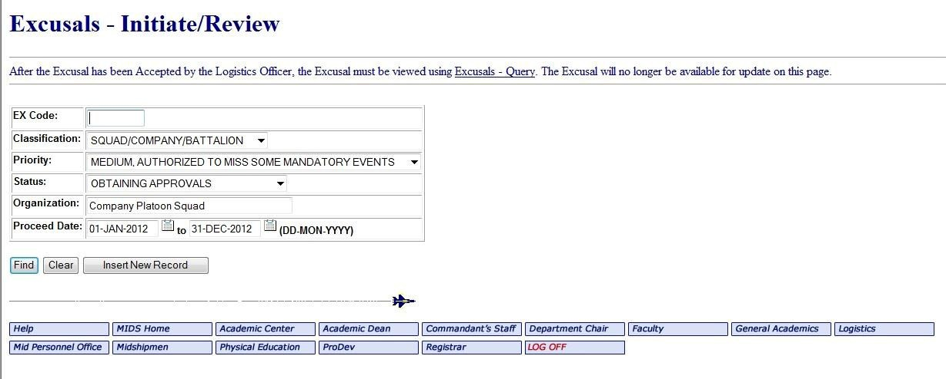

- Click Insert New Record
- Fill in the next form as shown below including your squad inning’s plans. Be complete but concise
- Your O-Rep and POC can be your SEL or Company Officer
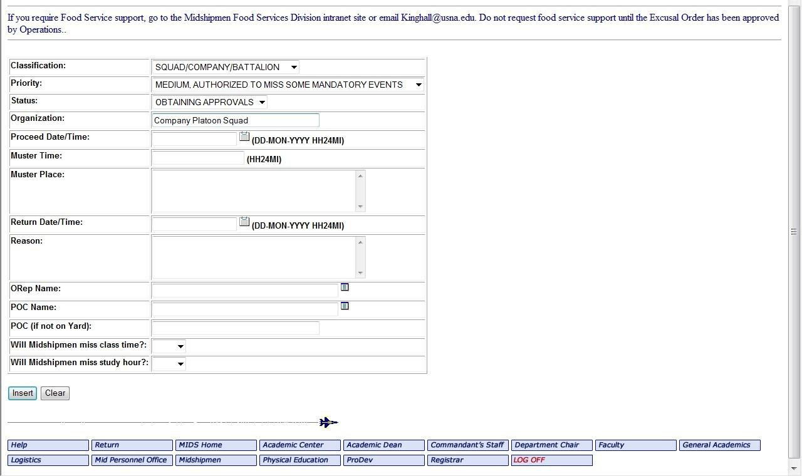

- Click Insert

You have now created an Excusal/MO. Note your assigned Excusal/MO number is at the top of the MIDS screen.

- You will get an automated email once your Excusal/MO is approved
- You can scroll down to add squad members to your Excusal/MO by selecting one of these methods
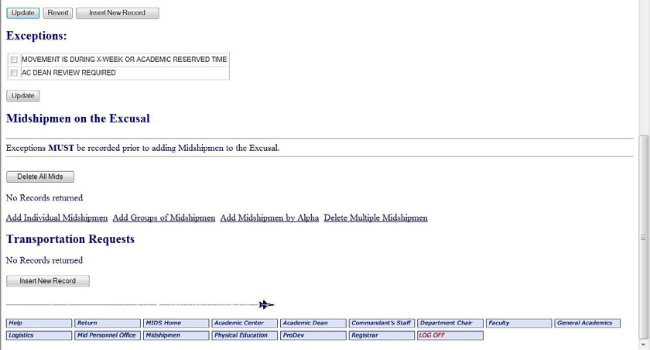

Third: Write a Special Request Chit, ORM, and Movement Order

- For Innings only: Write a Special Request Chit and route it through your Chain of Command. Include the Excusal number
- For Outings only: Include an ORM chit with the Special Request Chit. Include the MO number

Fourth: Notify King Hall (if necessary)

Plan squad innings/outings around mandatory meals. You must have both Company Officer and Commandant Operations approval if missing mandatory meals or events. If your squad is approved to miss a mandatory meal, notify LT Andreoli (andreoli@usna.edu) and cc Ms. Trish Withrow (withrow@usna.edu) with the following information:

- Date that table should be cancelled
- Meal that should be cancelled
- Excusal/MO Number
- Table Number

NOTE: MFSD will not provide any funding for meals outside of King Hall that are under company size (USNAINST 1746). Additionally, make sure that your Excusal/MO is approved by Commandant Operations; otherwise, you will be expected to eat at your table in King Hall.

Squad Activities

1. The Importance of Squad Activities. As the semester progresses, the squad members will become overwhelmed with commitments outside of the company. This can lead to the gradual drifting apart of squad members. The squad leader is responsible for bringing the squad together regularly through squad activities designed to release stress and improve morale. Squad activities can cut the monotony of daily activity while building unit cohesiveness.

2. Squad Innings. These ideas are perfect for weeknights or Friday nights when not everyone in the squad has liberty, or you want to plan an event that can take place entirely on the yard.
- Concerts. Take the squad to see a concert on the yard. This can be accomplished when the Distinguished Artist Series is running. Tickets can be purchased for discounted prices through the Ticket Office. Other ideas are to go to Glee Club or Gospel Choir concerts.

- Dahlgren Night. Organize a sports night in Dahlgren for your squad to watch a heated basketball game or football game. Or reserve the MAC and play pool and foosball. These are great ways to get out of company area while still remaining on the yard. Squad members may feel comfortable getting to know more about each other in this setting.

- Picnic/Barbeque at Hospital Point. Throwing a picnic or BBQ at Hospital Point may be an event more suited to an entire platoon. Get your squad or platoon excused from Sunday EMF and have everyone meet instead at Hospital Point for a delicious fall or spring picnic/BBQ. Hospital Point has grills and a large buffet table as well as a covered area with tables in case of bad weather. Bring out a Frisbee and play games at the same time.

- Squad vs. Squad Sports Events. Get a little friendly competition going with another squad and organize a squad vs. squad sports event from 1900-2000 on a weeknight. Invite other squads in the company to cheer on their friends and offer a prize to your squad if they win.

- USNA Musical or Masqueraders Events. Organize a squad inning to see a USNA musical or masqueraders production together. This is a particularly great idea if one of your squad members or company mates is involved in the production.

- USNA Sporting Events. Go as a squad to a USNA sporting event either on the yard or at USMC stadium. This is also a great idea if one of your squad members is an athlete.

- Wardroom Movie Night. Order pizzas, get your squad excused from EMF, and watch a movie in the wardroom. This squad inning can deteriorate if people pop in for pizza and leave to do homework. Encourage the squad to stay together and maybe organize the movie night for a Friday night so that people are less likely to leave to do work.

3. Squad Outings. These are a few suggestions close to the Academy:
- Annapolis, Baltimore, and other Maryland Locations
  - The Baltimore Museum of Art
  - Bowie Baysox Baseball Game
  - Inner Harbor, Baltimore
  - Maryland Science Center Medieval Times
  - National Aquarium, Baltimore
  - Orioles Game
  - The Walters Art Museum
  - Camping at NSA
- Washington, DC Area
  - International Spy Museum
  - National Zoo
  - National Air and Space Museum
  - National Mall
  - Smithsonian Institute
  - Washington Capitals
  - Washington Nationals
  - The White House
- Virginia
  - Colonial Williamsburg, VA
  - Arlington National Cemetery
  - The National Museum of the Marine Corps
18900 Jefferson Davis Hwy, Triangle VA 22172
(703)-432-1775
- Pennsylvania
  - Blue Knob Ski Packages
  - Liberty/Roundtop/Whitetail/Wyndham Skiing
  - Hershey Park
  - Gettysburg

4. Contact Information
- The Baltimore Museum of Art
10 Art Museum Drive, Baltimore, MD 21218
(443) 573-1700
http://www.artbma.org/index.html
- Founded in 1914, The Baltimore Museum of Art is a major cultural destination recognized for engaging diverse audiences through dynamic exhibitions and innovative educational and community outreach programs.
- The BMA’s internationally renowned collection of 95,000 objects encompasses more than 1,000 works by Henri Matisse anchored by the famed Cone Collection of modern art, as well as one of the nation’s finest holdings of prints, drawings, and photographs. The galleries showcase an exceptional collection of art from Africa; important works by established and emerging contemporary artists; outstanding European and American paintings, sculpture, and decorative arts; ancient Antioch mosaics; and exquisite textiles from around the world.
- The 210,000-square-foot museum is distinguished by a grand historic building designed in the 1920s by renowned American architect John Russell Pope and two beautifully landscaped gardens featuring an array of 20th-century sculpture.
- The BMA is located in Charles Village, three miles north of the Inner Harbor, and is adjacent to the main campus of Johns Hopkins University.
- General admission to the BMA is free so that everyone can enjoy the power of art.
- Blue Knob Ski Packages
1424 Overland Pass, Claysburg, PA 16625
(814) 239-5111
http://www.blueknob.com/
- Blue Knob is home to Pennsylvania’s highest skiable mountain. MWF offers reduced prices.
- Bowie Baysox Baseball Game
Prince George Stadium, 4101 Crain Highway, Bowie, MD 20716
(301) 464-4911
- Naval Station MWR offers free or reduced price tickets.
- Colonial Williamsburg, VA
Colonial Williamsburg Regional Visitor Center
101-A Visitor Center Drive, Williamsburg, VA 23185
(888) 965-7254
- Take a trip to colonial Williamsburg to explore museums, historical buildings, and outdoor shows all run by colonial re-enactors. MWF and Naval Station MWR offer reduced price day passes.
- Gettysburg Battlefield and Campground
Gettysburg/Battlefield KOA
20 Knox Road, Gettysburg, PA 17325
(717) 642-5713
- Rent tents and sleeping bags from MWR (which many MIDS don't know about) at the Naval Station.
- International Spy Museum
800 F Street Northwest, Washington, DC 20004
(202) 393-7798
http://www.spymuseum.org/
- The International Spy Museum, a museum exploring the craft, practice, history, and contemporary role of espionage, opened in Washington, DC on July 19, 2002. The International Spy Museum is the only public museum in the United States solely dedicated to espionage and the only one in the world to provide a global perspective on an all-but-invisible profession that has shaped history and continues to have a significant impact on world events.
- The International Spy Museum features the largest collection of international espionage artifacts ever placed on public display. Many of these objects are being seen by the public for the first time. These artifacts illuminate the work of famous spies and pivotal espionage actions as well as help bring to life the strategies and techniques of the men and women behind some of the most secretive espionage missions in world history.
- The mission of the International Spy Museum is to educate the public about espionage and intelligence in an engaging way and to provide a context that fosters understanding of their important role in and impact on current and historic events. The Museum focuses on human intelligence and reveals the role spies have played in world events throughout history. It is committed to the apolitical presentation of the history of espionage in order to provide visitors with impartial, accurate information. Ask for special military rates.
- Liberty/Roundtop/Whitetail/Wyndham Skiing
  - Beat the dark ages by taking the squad on a weekend outing to a nearby ski resort. Reduced prices are available through MWF.
- Maryland Science Center
601 Light Street, Baltimore, MD 21230
(410) 685-5225
http://www.marylandsciencecenter.org/
- Dinosaurs, Planet Earth, the Human Body, Outer Space, Chesapeake Bay life…these are only a few of the exhibits available through the Science Center. Take the squad to explore the please touch environment and then check out an IMAX movie.
- Medieval Times
7000 Arundel Mills Circle, Hanover, MD 21076
(888) 935-6878
http://www.medievaltimes.com/
- Take the squad to Medieval Times for a banquet and tournament they will remember. MWF offers reduced price tickets.
- National Air and Space Museum
595 Independence Avenue Southwest, Washington, DC 20560
(202) 633-2214
http://www.nasm.si.edu/
- Visit the Wright Brothers’ 1903 Flyer, Lindbergh’s Spirit of St. Louis, Apollo 11 Lunar Command Module, and other national treasures.
- National Aquarium, Baltimore
501 E Pratt St, Baltimore, MD 21202
(410) 576-3800
http://www.aqua.org/
- Conveniently located in the world famous Inner Harbor, the National Aquarium is home to thousands of aquatic creatures. Explore the Aquarium and then go for dinner on the Inner Harbor.
- Tickets are $10 for midshipmen through MWF.
- National Mall
900 Ohio SW, Washington, DC 20024
(202) 245-4660
http://www.nps.gov/nacc/planyourvisit/index
  - The National Mall encompasses the Washington Monument, the Lincoln Memorial, and the WWII Memorial as well as many others. Plan an outing on a beautiful day to explore this area before heading to dinner.
- Six Flags America
13710 Central Ave, Upper Marlboro, MD 20774
(301) 249-1500
www.sixflags.com/america/
- Reduced prices available through MWF.

- Smithsonian Institute
1000 Jefferson Drive SW, Washington, DC
(202) 633-1000
http://www.si.edu/
  - Visit one of 19 museums and the National Zoo right in the DC area.
- The Walters Art Museum
600 North Charles Street, Baltimore, MD 21201
(410) 547-9000
http://thewalters.org/
  - The Walters Art Museum in Baltimore, Maryland is internationally renowned for its collection of art. The collection presents an overview of world art from pre-dynastic Egypt to 20th-century Europe, and counts among its many treasures Greek sculpture and Roman sarcophagi; medieval ivories and Old Master paintings; Art Nouveau jewelry and 19th-century European and American masterpieces. General admission is FREE!
- Washington Capitals
Verizon Center
610 F Street, Washington, DC
(202) 628-3200
www.capitals.nhl.com
  - Check out the website for the season schedule of Washington, DC’s hockey team.
- Washington Nationals
Nationals Park
1500 S Capitol Street SE, Washington, DC 20003
https://www.mlb.com/nationals
  - Check out the website for the season schedule of Washington, DC’s baseball team.
- The White House
1600 Pennsylvania Avenue, Washington, DC
https://www.whitehouse.gov/participate/tours-and-events
  - Tours can be requested through your Congressional Office up to three months in advance.

References

- Weekly Update Sheet

- Individual Development Plan

- Midshipman Counseling Form (Form 1):

  - Official document found in COMDTMIDNINST 1610.2H

- Responding to a Disclosure of Sexual Assault

Weekly Update Sheet

Name:______________________________________________________ Date:_____________

Platoon/Squad: ACADEMICS

Grades Received in the past week | Class | Test, Paper, Quiz, Topic?

ATHLETICS
Did you have any competitions this week? What was the result/how did you do?

PERSONAL
Upcoming events this week (tests, sporting events, appointments, etc.):

Weekly Challenge and course of action to achieve this goal:

Questions/Comments/Feedback:

Individual Development Plan

Name: ______________________________ Supervisor: ___________________________

Planning Period: _________________

Development Goals | Action Plans – Developmental  Activities & Resources  (what, who & how) | Time Line  (Target  Dates) | Criteria for Success  (What will successful outcomes be?)

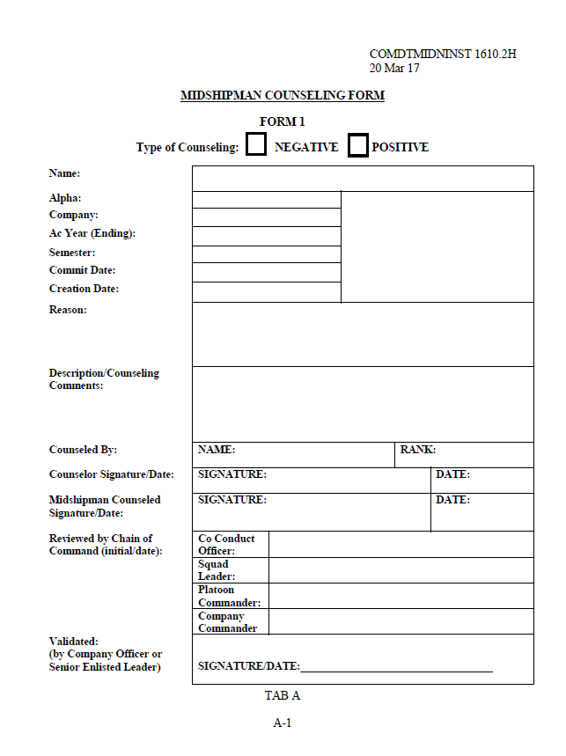
Midshipman Counseling Form (Form 1)

Responding to a Disclosure of Sexual Assault

1. Does the person need medical attention or in immediate danger? If so call 911.

2. Call, or assist the survivor in calling, a SARC or a Victim Advocate.

a. SARC - (443) 336-5359

b. 24/7 Duty Victim Advocates - (443) 336-2637

3. In order to ensure the restricted report option and the privacy of this person, do not speak to anyone else in your department or chain of command about the incident.

4. LISTEN and support the survivor. Tend to his/her immediate needs; stay with him/her until a SARC or Victim Advocate, medical, etc. arrives; listen without judgment.

5. Treat the suspected offender as innocent until proven guilty and protect the survivor’s legal rights.

6. For further information and resources you can access these websites:

a. http://intranet.usna.edu/SAPRO/ (if at USNA)

b. https://www.safehelpline.org/

Notes

Notes

Notes

